

UNITEDWORLD INSTITUTE OF TECHNOLOGY (UIT)

**End-Semester Practical**

Submitted by

Patel Zalak Bipinkumar

20220701020

**Data Visualization**

**(21BSCS35C02)**

B. Sc. Computer Science -DS/AIML

V Semester, July -Nov 2024



November 2024

Contents

1. To study about various products of Tableau, create your account, Installing and setting up Tableau. 2

2. To study about Data Connection and Connecting to different data sources in Tableau like try to Import Dataset from 1. Excel 2. PDF 3. Text File etc. 3

3. Import Dataset into Tableau and create relationship between tables. 6

4. Creating a basic bar chart to visualize sales data. 7

5. Customizing the bar chart by adding labels and tooltips. 8

6. Create a Pie Chart for Sales Data and customize it using colour scheme, Label, size. 9

7. Creating a line chart to analyze sales trends over time. 10

8. Building a scatter plot to explore the relationship between two variables. 11

9. Creating a stacked area chart to analyze Sales Data. 12

10. Visualizing categorical data using a bubble chart. 13

11. Creating a Tree map using Tableau and working with data, filter, sorting. 14

12. Create a geographic Map using Tableau and highlights all relevant states/Cities with label. 15

13. Creating a heat map to identify patterns or correlations in data. 16

14. Implementing dual-axis charts to compare two metrics with different scales 17

15. Applying advanced calculations and functions for customized metrics. 18

16. Create minimum six worksheets for data visualization in Tableau using Sales Dataset. 19

17. Designing a comprehensive dashboard with multiple visualizations for Sale Dataset. 23

18. Prepare a census dataset (data must be actual as per Gov portal), generate maps geographical, Bar Chart, Pie Chart, Bubble Chart visualization using Tableau and Create a Complete Dashboard. 23

19. Prepare a City wise Air Quality Index dataset and generate visualization using Tableau. Try to use maximum functions available in Tableau 1. Colour 2. Label 3. Filter 4. Sorting 5. Swap Row Column 6. Size of objects. 27

20. Create a Dashboard for AQI Visualizations. 30

21. Apply BG Color, Float, Add filter, Add links/Image, Add Download button, Add navigations, on your AQI Dashboard. 34

22. Creating a data story on census dataset using Tableau's story features. 35

23. Designing annotations and add captions to enhance your data story. 36

24. Create a Data Story for City wise Air Quality Index data. 37

25. Create a Data Story for Sale Data. 37

26. Create a Complete Dashboard and Story for Customer Segmentation Dashboard. 38

27. To study about extensions in Tableau Dashboard and try to use any two extensions. 39

28. Apply Data Blending to combine data from multiple sources to create a unified visualization, such as integrating sales data with customer demographics. 40

29. Create a comprehensive Dashboard and Story for Analysing Marketing Campaign Impact on Sales. 40

30. Create a comprehensive Dashboard and Story on Social Media Analytics. 42

## To study about various products of Tableau, create your account, Installing and setting up Tableau.

## 

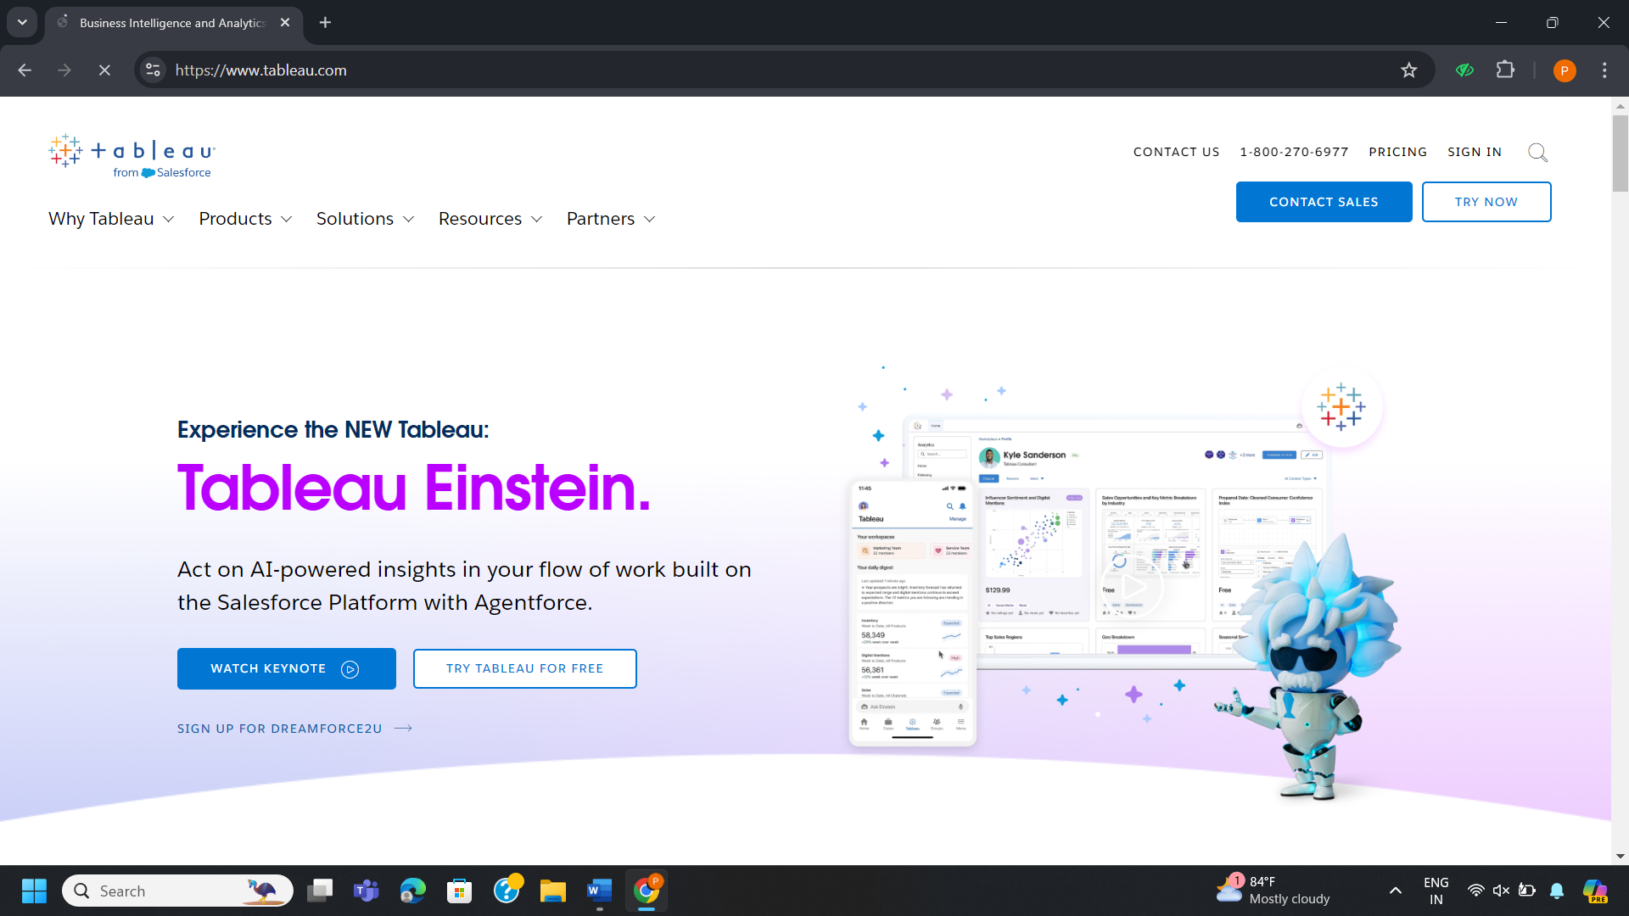

**Creating a Tableau Account**

* Visit Tableau's official website. Through Tableau for Students portal, you may obtain Tableau cost-free if you are a student. If not a student, you'll have the option of buying a license or using a free trial version. If you want to use a trial version, click "Free Trial". Enter your name, email address, company, and any other information that is asked. For login information and a confirmation, check your email.

**Installing Tableau**

* After creating an account, select Tableau Desktop (or Tableau Public for a free version). Open the downloaded.exe file on Windows. Observe the instructions on the screen, you will be guided through the installation procedure by the setup.

**Setting Up Tableau**

* Launch Tableau from the installed applications. To log in, use your login credentials (password and email). You'll be asked to establish a connection to a source of data after logging in. Databases, Excel, CSV, and even data stored in the cloud are all options.

**Studying Tableau Products**

**Tableau provides a range of products based on user requirements:**

* **Tableau Desktop:** A strong tool for connecting, visualizing, and analyzing your data.
* **Tableau Public:**A free version for making visuals that the public can see.
* **Tableau Server:** To share and work together on dashboards inside your company.
* **Tableau Online:** A cloud-based dashboard hosting solution.
* **Tableau Prep:** A data preparation and cleaning tool for use prior to analysis.

## To study about Data Connection and Connecting to different data sources in Tableau like try to Import Dataset from 1. Excel 2. PDF 3. Text File etc.

**Connecting Tableau to Various Data Sources**

* Tableau is a versatile platform that enables users to establish connections with multiple data sources. Numerous file kinds, including Excel, PDFs, text files, and databases, can be used to import data. Tableau's Connect pane, which shows accessible data sources on the left side of the interface, can be used to establish each sort of connection.

**Importing Excel dataset:**

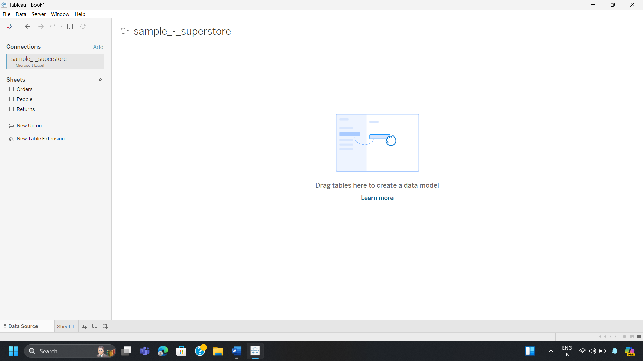

* You can link to Excel files with ease using Tableau. The example file in Excel ("sample - superstore") has been linked, as seen in the image. "Orders," "People," and "Returns" are among the sheets that are accessible on the sidebar.
* Go to the "Data" menu and choose "Microsoft Excel" within the "Connect" choices to import an Excel file. You can choose the file from your system as a result.
* After the file is linked, each Excel sheet shows up in the left-hand pane. You can then drag and drop each sheet into the data workspace to perform additional analysis or build a data model.

**Importing PDF dataset:**

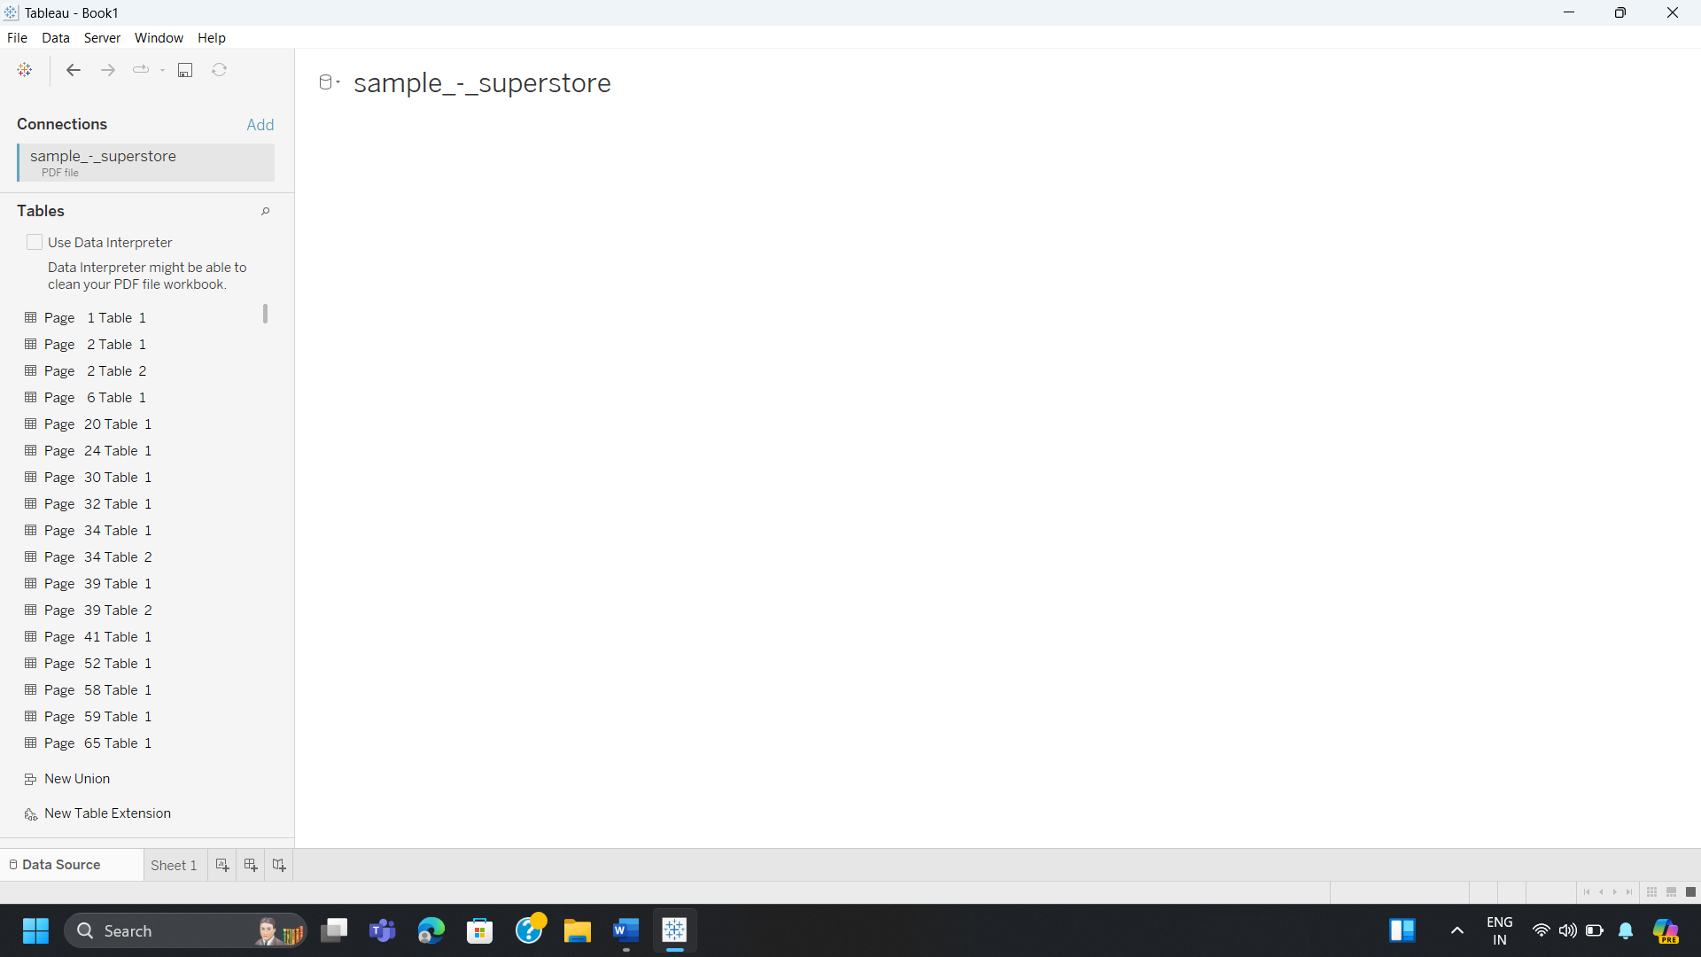

* Tableau has the ability to import data from PDFs, as the shown in image. The PDF automatically identifies each page as a table (for example, "Page 2 Table 1").
* Choose "PDF File" from the "Data" menu to establish a connection to a PDF. Each page's data tables will be extracted by Tableau, allowing for analysis and visualization.
* You can use the integrated Data Interpreter to help organize jumbled PDF data.

**Importing Text File dataset:**

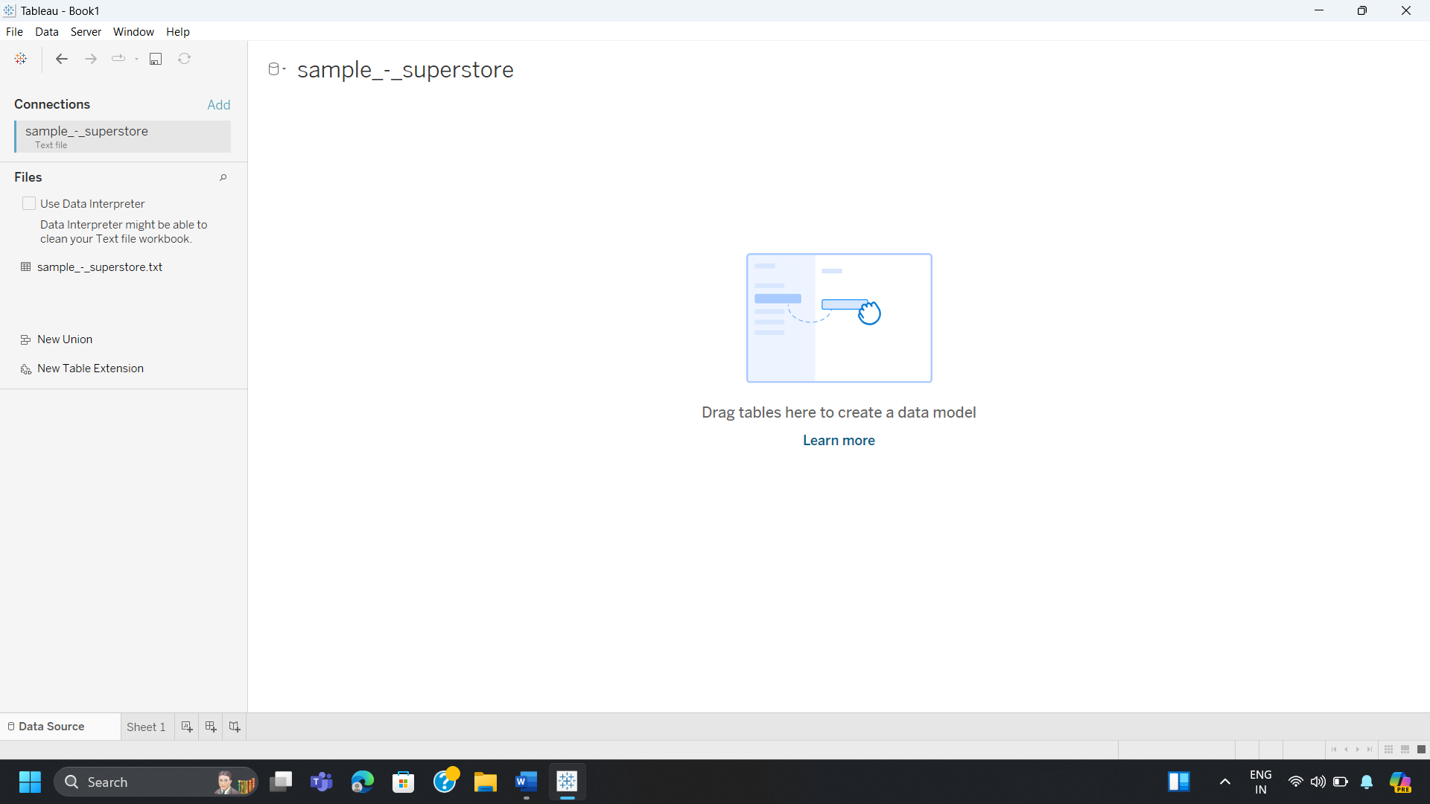

* A connection to a text file ("sample - superstore.txt") is displayed in the image. Tableau is capable of handling multiple text file types, such as CSV and tab-delimited files.
* You may begin creating data models and visualizations in Tableau once you've established a connection to a text file and seen its contents.
* Simple datasets or flat file databases can be imported using text files. Before starting an analysis, you can also allow the Data Interpreter to clean and organize the data.

## Import Dataset into Tableau and create relationship between tables.

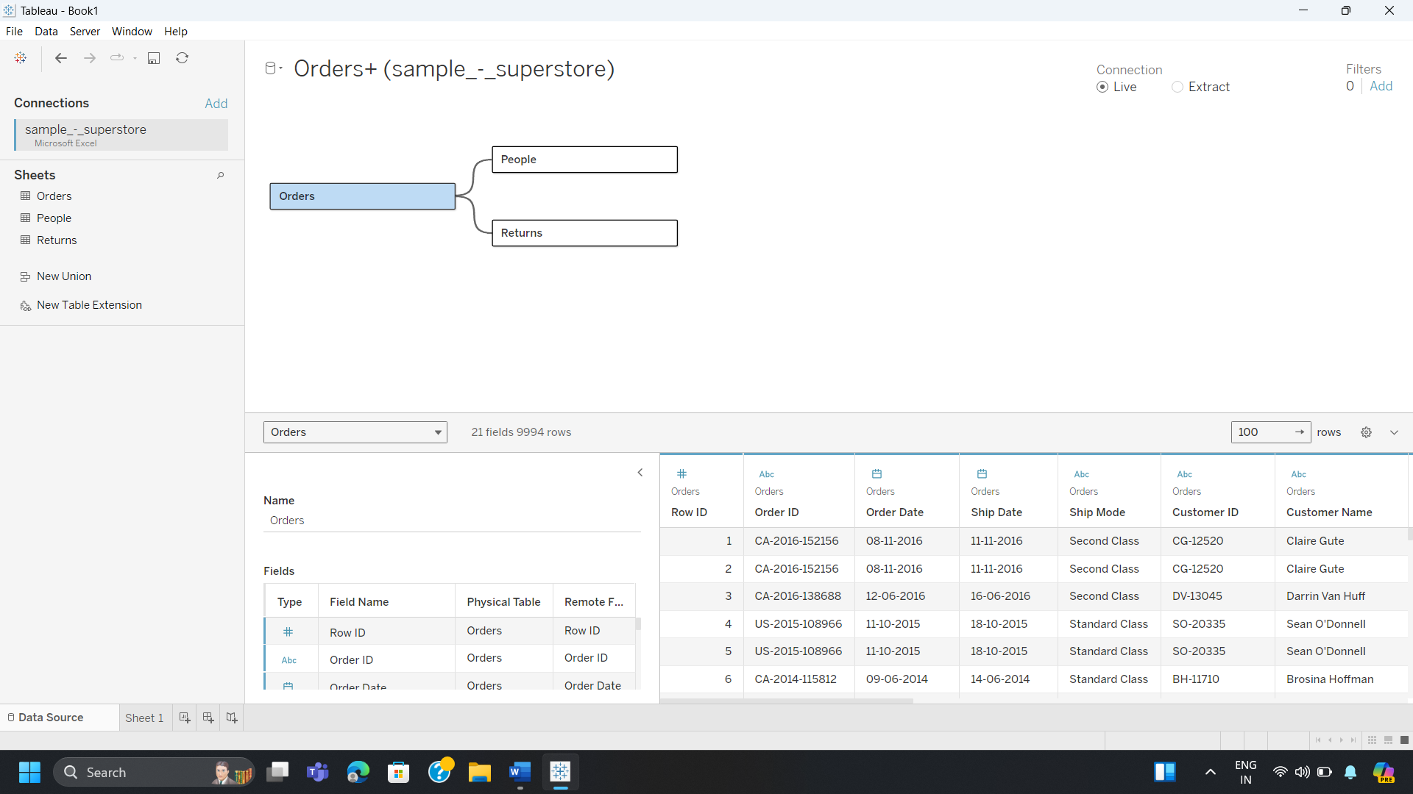

**Importing Dataset:**

* Tableau was opened and the "Sample - Superstore" data was loaded. The Orders, People, and Returns sheets are among the many sheets that make up the dataset. These sheets include many data points for analysis, including order details, client information, and records of returns. These tables may be seamlessly integrated with Tableau to carry out interactive data analysis.

**Creating Relationships:**

* Tableau's Data Model functionality was used to construct links between the Orders, People, and Returns tables when the dataset was imported. Using customer IDs, the Orders table was linked to the People table, and order details were used to link Returns to the Orders table. Tableau can dynamically connect and analyze data across different tables thanks to these relationships, guaranteeing consistent and insightful findings.

## 4. Creating a basic bar chart to visualize sales data.

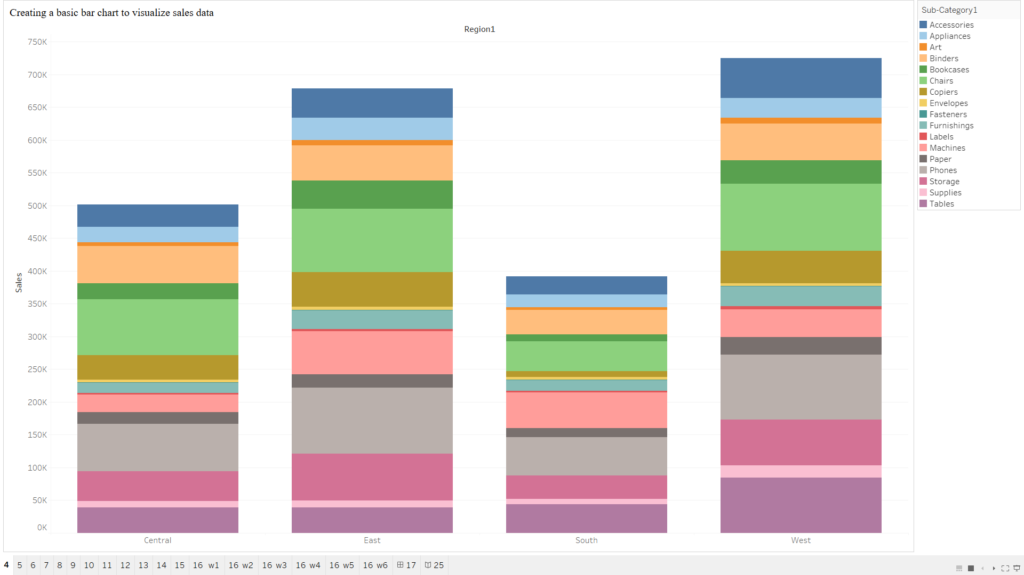

* Tableau was used to construct a simple bar chart that showed sales data by area. When comparing values across categories, this kind of chart can be helpful in seeing patterns or trends in the data.
* **Rows and Columns:** The SUM(Sales) field was positioned on the Rows shelf, and the Region field was dragged to the Columns shelf. With this configuration, total sales by region are displayed in a vertical bar chart.
* **Color & Marks:** The Sub-Category field was added to the Color Marks card, which colors the bars according to product sub-categories, to improve the display. This makes it possible to break down sales performance in each region more thoroughly and provides information on the contributions made by specific subcategories to overall sales.
* **Formatting and Labels:** To improve the chart's clarity, sales value labels were added to the bars. The chart's gradient color style facilitates visual comprehension of the data distribution by helping to differentiate between various sales levels within each subcategory.

## 5. Customizing the bar chart by adding labels and tooltips.

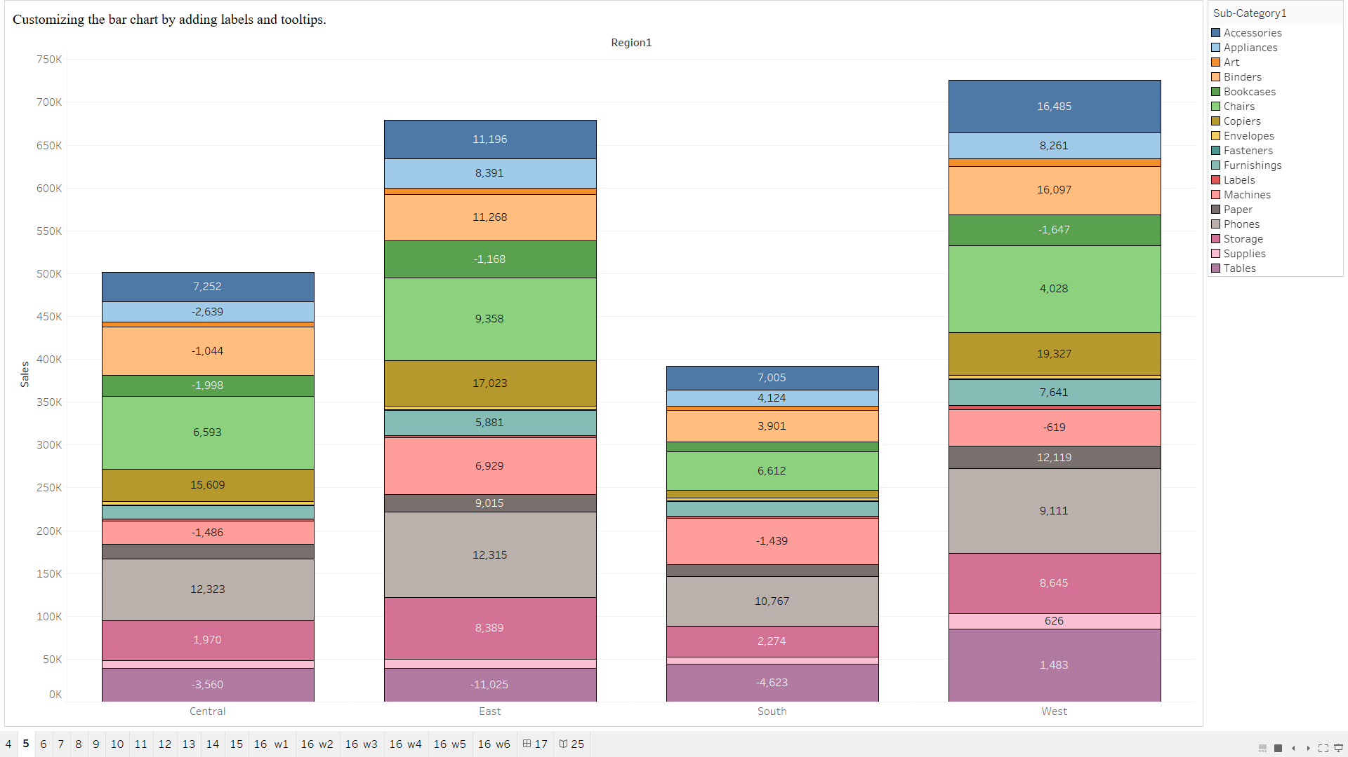

* To improve its clarity and interactivity, alterations were made to a basic bar chart that was created to display sales data. Adding labels and tooltips to the chart allowed for direct visualization of more in-depth information.
* **Labeling:** To display precise values for Sales, Quantity, and Profit, labels containing sales data were appended to every bar. Dragging the pertinent fields (SUM(Quantity), SUM(Profit)) onto the Label markings card allowed for this. For every subcategory within the areas, the labels give a detailed breakdown of sales volume, quantities sold, and profit margins. This facilitates chart interpretation without necessitating further engagement.
* **Tooltips:** When a tooltip is hovered over a bar, it now displays more extensive information according to customization. The user can examine additional metrics in the tooltip window, such as total units sold and profit numbers, alongside sales data by adding Quantity and Profit entries to the Tooltip markings card. As a result, the data may be explored more thoroughly without visually clogging the display.
* **Enhanced Visual Insights:** By including several levels of information into the bar chart in a user-friendly and interactive way, the labels and tooltips work together to improve it. This adjustment enhances the chart's general usability and interpretability by enabling users to obtain summary and comprehensive data fast.

## 6. Create a Pie Chart for Sales Data and customize it using colour scheme, Label, size.

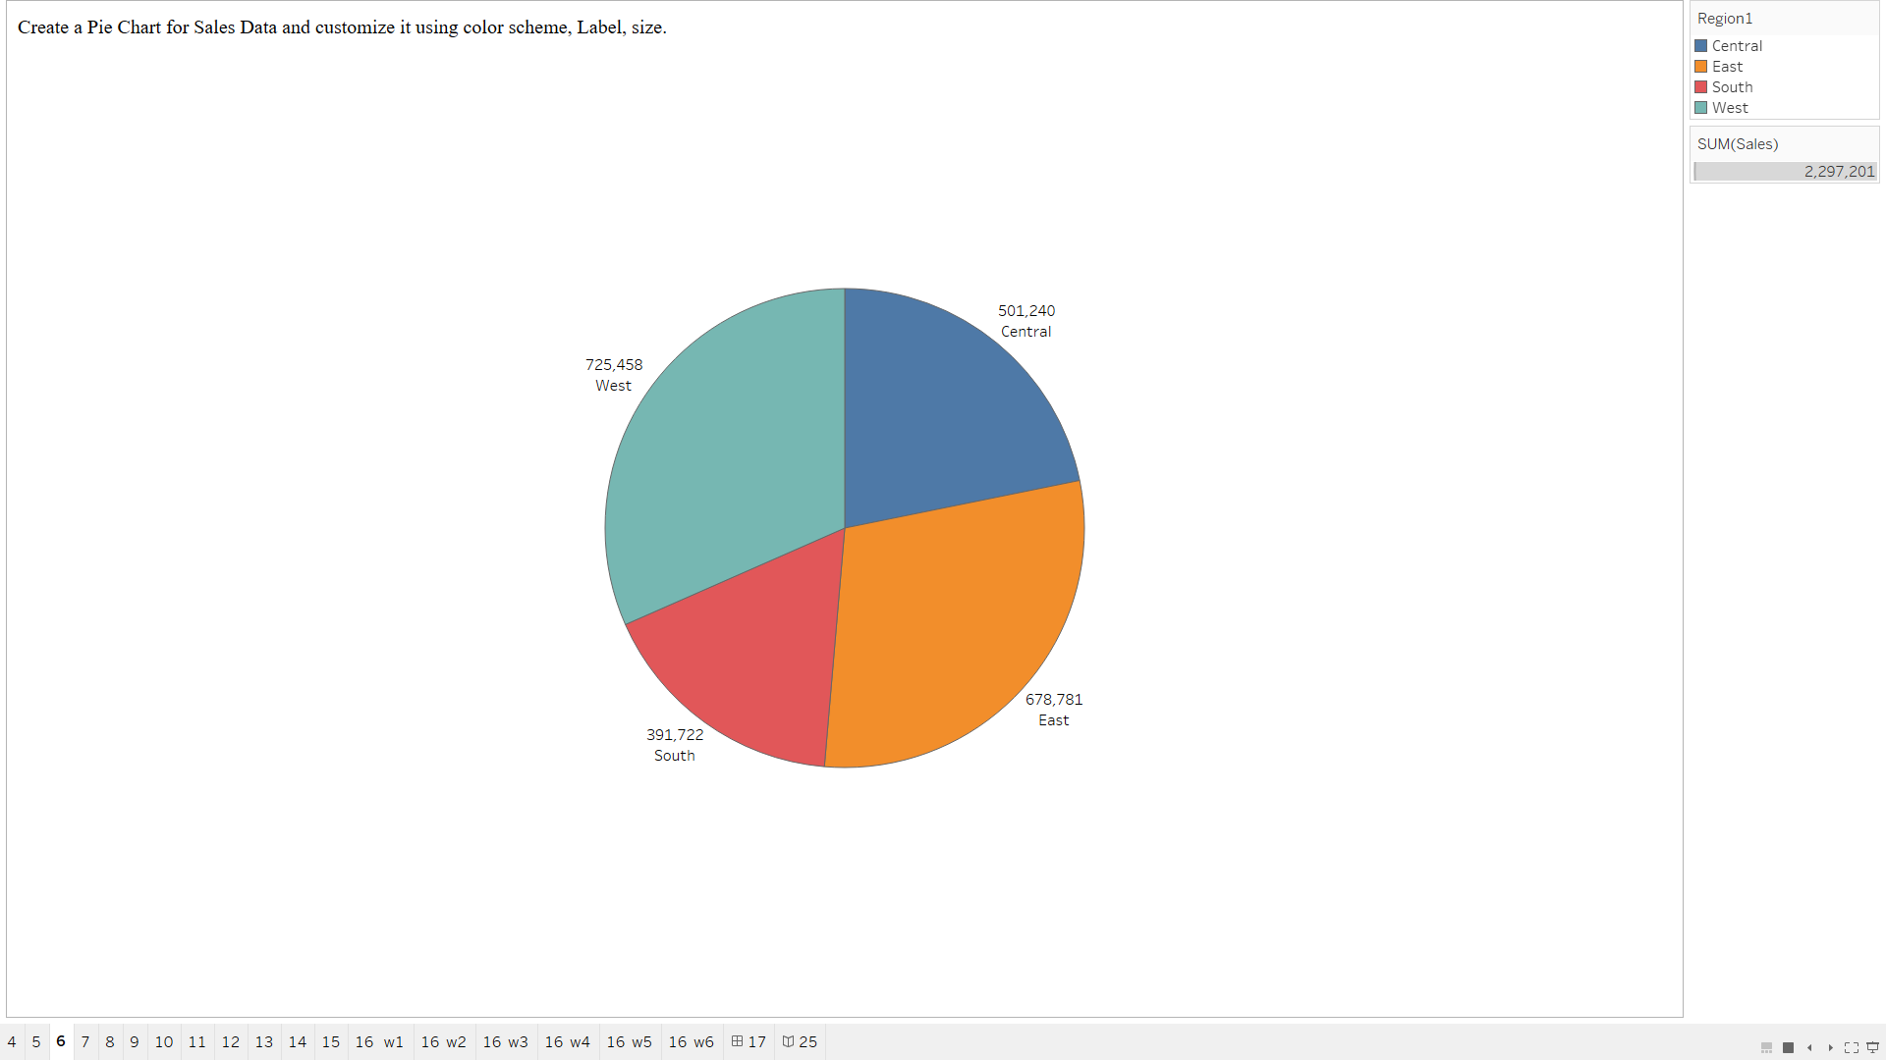

* The distribution of sales throughout the four regions—Central, East, South, and West—is depicted in the pie chart. For clarity, labels and values are displayed alongside the data points, which show the total sales for each region. To distinguish the regions, a unique color scheme has been added to the graphic.
* **Central Region:** Sales Total: $501,240. The Central region contributes a significant portion of the overall sales, representing a sizable section of the chart.
* **East Region:** Sales Total: $678,781. The East region shows a prominent sales volume, second only to the West region in terms of contribution.
* **South Region:** Sales Total: $391,722. The South region has the smallest sales figure among the four regions.
* **West Region:** Sales Total: $725,458. The West region leads in sales, representing the largest portion of the pie chart.
* **Customization of Visualization**

**Color Scheme:** The data is easily separated and analyzed visually because each section is represented by a different color.

**Labels:** Direct sales data visualization on the chart offers instantaneous insight into the performance of regional sales.

**Dimensions of Size:** The visual reinforcement of the regional comparison is achieved by the size of each pie slice matching the sales volume.

* **Total Revenue** The total of the sales values shows that the total sales for all regions are $2,297,201.

## 7. Creating a line chart to analyze sales trends over time.

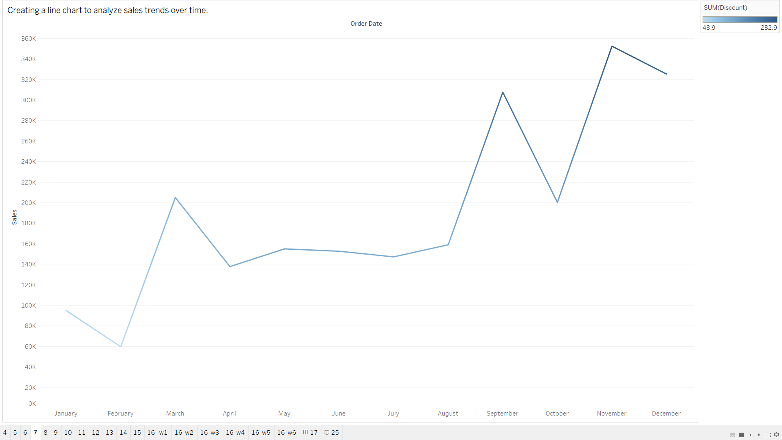

* With monthly data points reflecting the variation in sales over the course of the year, the line chart illustrates sales trends over time. An understandable view of sales performance and seasonality is given by this graphic.
* **X-Axis (Order Date):** Indicates the timeframe over which sales are tracked by displaying the months of January through December.
* **Y-Axis (Sales):** Shows the monthly total sales value, which ranges from $0 to almost $350,000.
* **Analysis of Sales Trends:**Lower sales numbers for January and February suggest a sluggish start to the year.a notable spike in March, a decline, and a largely consistent stretch from April to August.a notable uptick in September, when sales reached an all-time high; this was followed by considerable volatility, with another peak occurring in October and November. December sales show a small decline, although they are still very high when compared to previous months.
* **Important Notes:** The March, September, and November growth periods are highlighted in the chart; these could represent seasonal peaks or particular business cycles that are causing higher sales. Before the upward rise in sales in the latter part of the year, there was a continuous trend in the relatively modest and stable sales between April and August.

## 8. Building a scatter plot to explore the relationship between two variables.

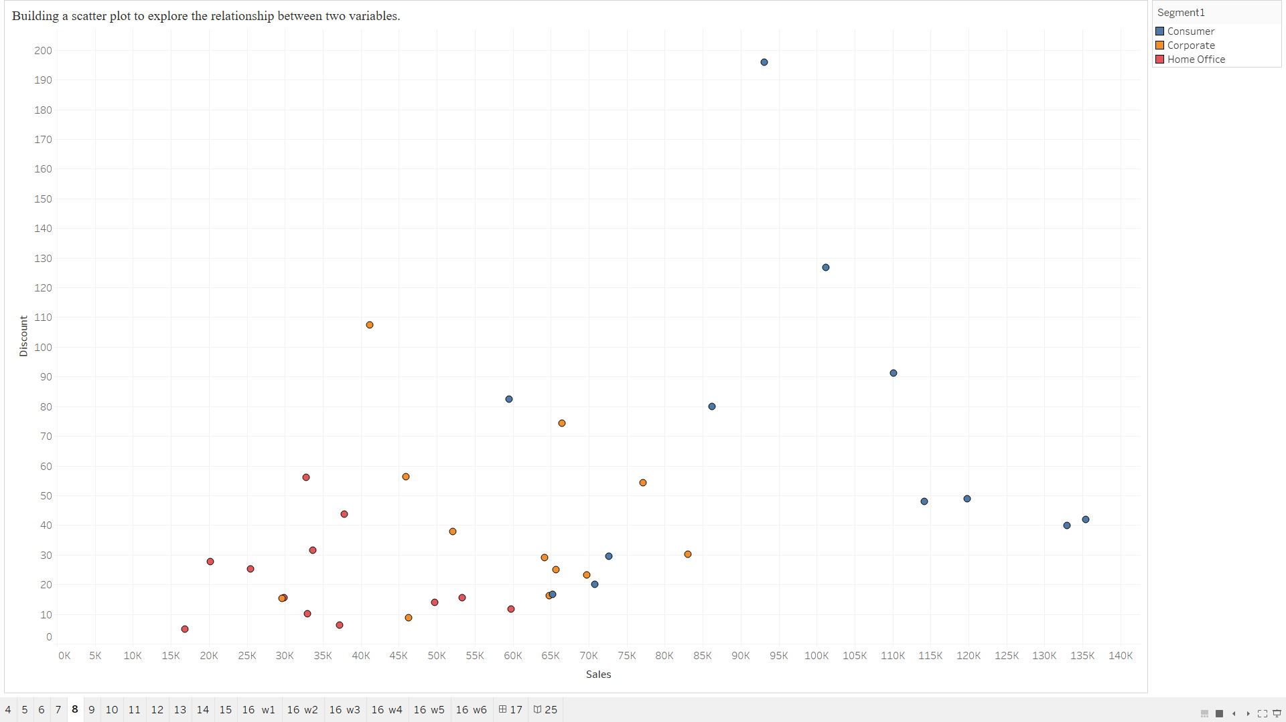

**Analysis of Sales vs. Discount by Segment using Scatter Plot**

* This scatter plot looks at the link between Discount and Sales to find patterns or trends in various client segments. The primary variables that are shown are:
* **Sales:** Shows the total quantity of sales on the x-axis.
* **Discount:** Shows the entire amount of the given discount (on the y-axis).
* Regionally shaped and colour-coded by Segment (Consumer, Corporate, and Home Office), each point in the scatter plot represents a distinct order.
* **Important Notes:**
* **Customer Sector:** This area, indicated by blue dots, seems to display a broad variety of sales values with different percentages of discount. Discounts range from modest to large for higher sales.
* **Corporate Segment:** Represented by orange dots, the Corporate segment shows moderate to high sales with relatively lower discounts.
* **Home Office Segment:** Represented by red dots, this segment generally shows lower sales values with moderate discounts.

## 9. Creating a stacked area chart to analyze Sales Data.

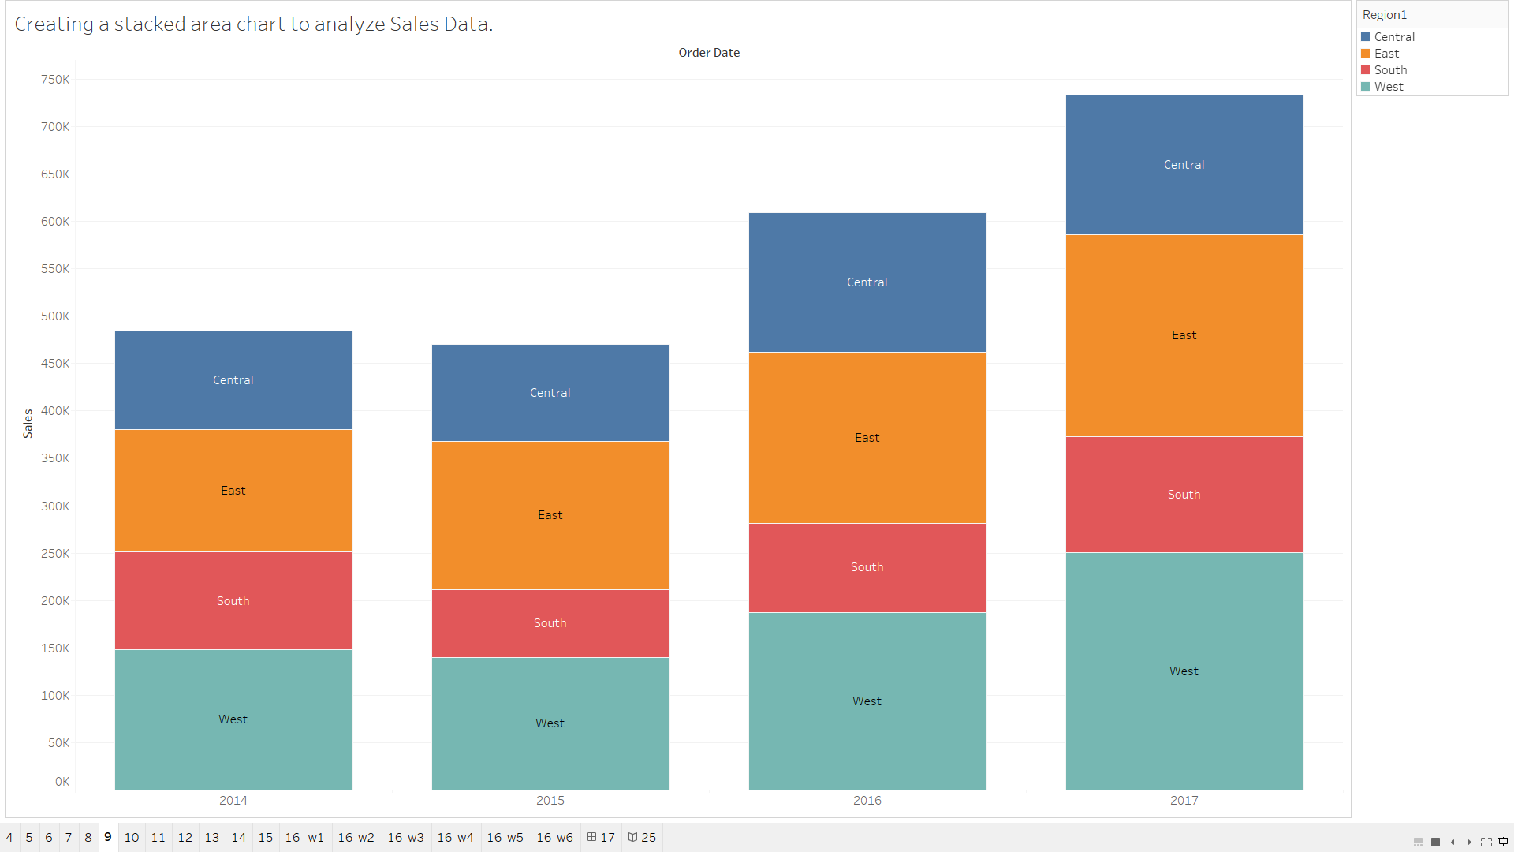

* **Regional Sales by Stacked Area Chart Over Time**
* From 2014 to 2017, the total sales by region are analysed in this stacked area graphic. The total sales are shown on the y-axis, while the order date (grouped by year) is represented on the x-axis. The stack's representation of the regions—Central, East, South, and West—is done using distinct colours, making it possible to compare how each region contributes to overall sales.
* **Important Notes:**
* Growth in Sales Over Time: Over the past four years, sales have increased steadily. Between 2014 and 2017, there was a noticeable increase in total sales volume.
* Regional Performance: Throughout all years, the East and Central areas have contributed the most significantly to overall sales.
* Despite having lower sales volumes, the West and South regions have steadily increased over time.
* With the largest sales in 2017, the Central region is crucial for generating income.
* Understanding the sales distribution throughout areas and how these contributions have changed over time is made easier with the aid of this visualisation. It is clear that while certain regions are dominating, others are expanding gradually, suggesting that there is room for more expansion in the future.

## 10. Visualizing categorical data using a bubble chart.

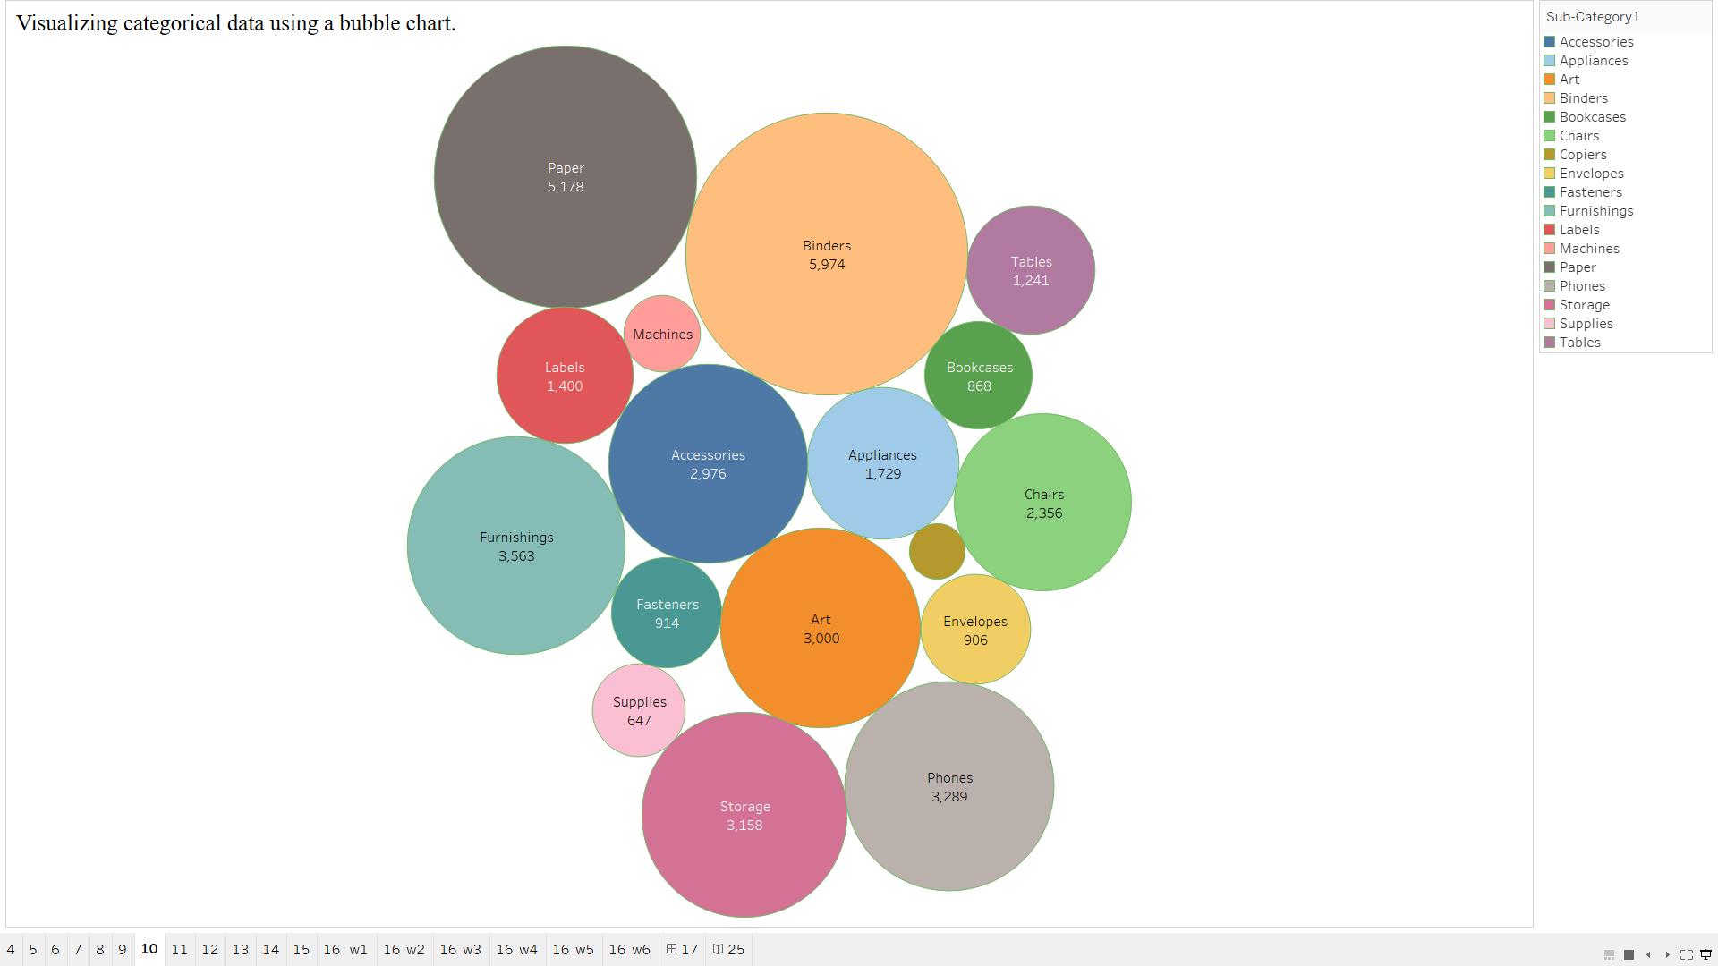

* **Product Sub-Category Bubble Chart by Quantity**
* A bubble chart based on the total quantity of products sold is used to display categorical data (Sub-Categories). Every bubble denotes a subcategory of products, and the size of the bubble indicates the quantity sold. Each bubble's colour designates a subcategory, making visual comparisons simple.
* **Important Notes:**
* **Leading Subcategories based on Quantity:**
* The biggest bubbles, representing the highest quantities sold, are found in the product categories of paper (5,178 units) and binders (5,974 units).
* Subcategories that are also very popular are Art (3,000 units), Phones (3,289 units), and Storage (3,158 units).
* **Mid-Level Categories:** Subcategories with moderate sales volumes, such as Chairs (2,356 units), Appliances (1,729 units), and Accessories (2,976 units), fall into this category.
* Smaller Categories:
* Fasteners (914 units) and Envelopes (906 units) have smaller bubbles, indicating relatively lower quantities sold compared to other categories.
* This bubble chart provides a clear and intuitive overview of which sub-categories dominate in terms of product quantity, helping identify popular product types as well as opportunities for increasing sales in smaller categories.

## 11. Creating a Tree map using Tableau and working with data, filter, sorting.

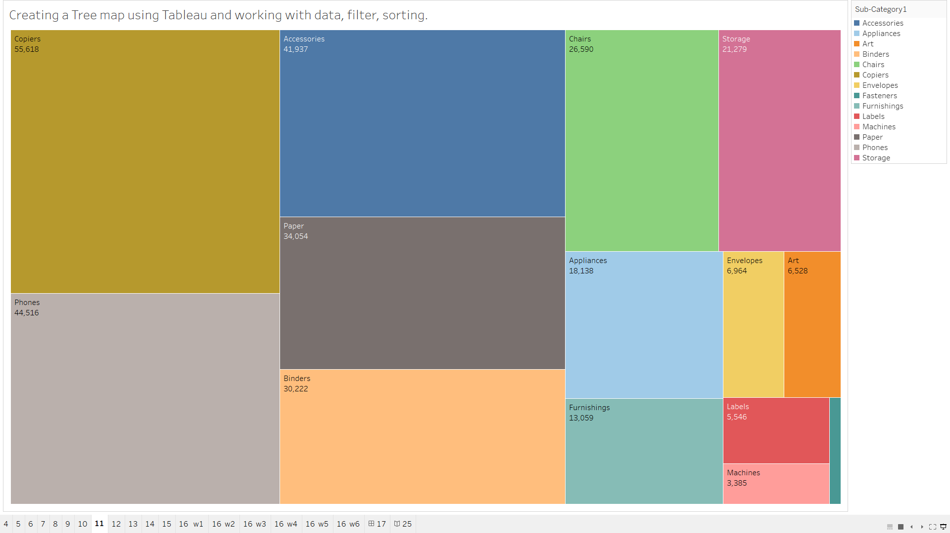

Based on their profitability, various product subcategories are shown visually in this chart.

* **Interpretation:** The size of each rectangle reflects the total profit made, and each rectangle indicates a sub-category within the data (e.g., Accessories, Phones, Binders).
* The color coding shows the spectrum of profits; yellow tones imply lower profitability, and darker green implies larger profit.
* **Data Filtering:** To guarantee that only profit information is displayed for each subcategory, the "SUM(Profit)" field has been added to the data.
* **Sorting:** Tableau automatically arranges the subcategories according to profit, making it possible to quickly see which subcategories have the greatest or least impact on profitability.

## 12. Create a geographic Map using Tableau and highlights all relevant states/Cities with label.

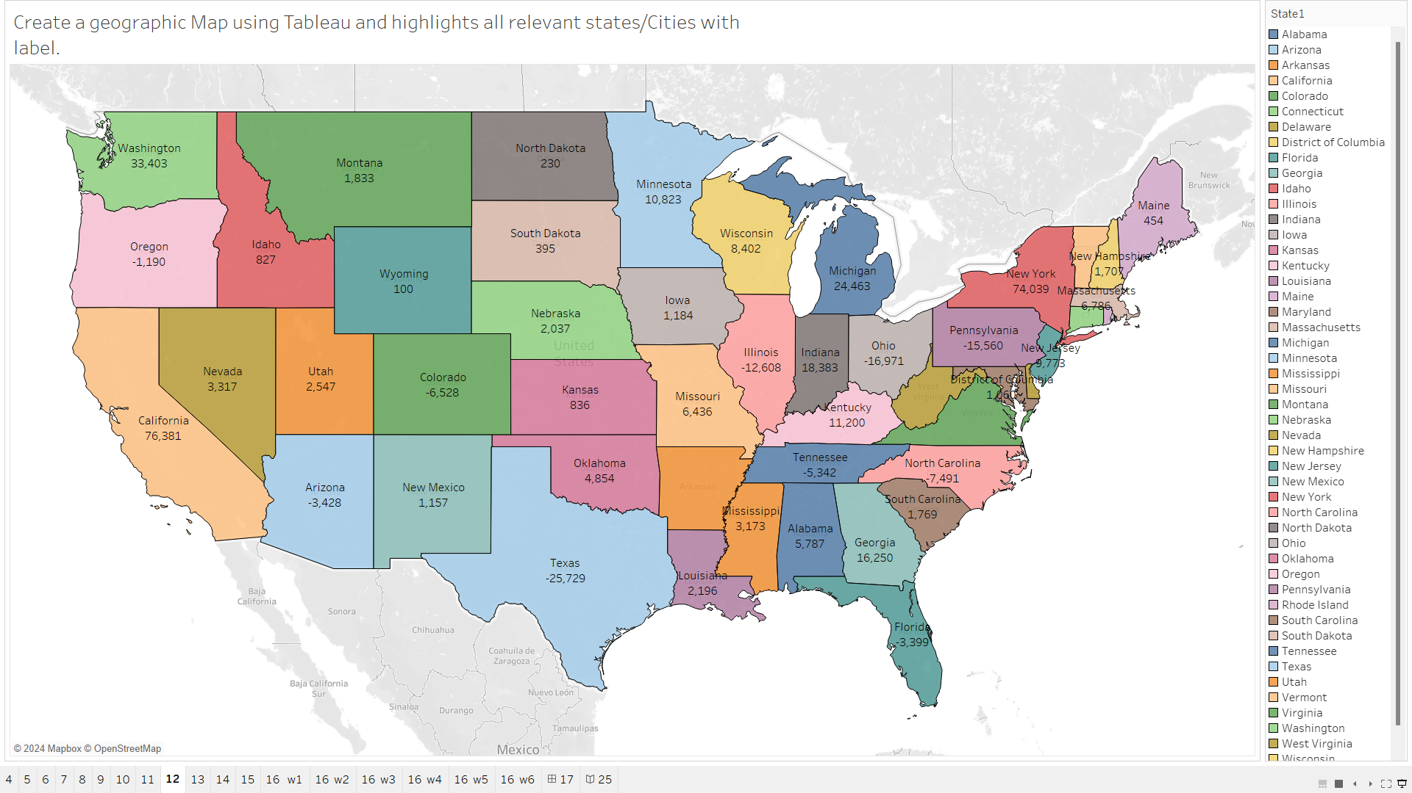

**Based on their profitability, various product subcategories are shown visually in this chart.**

* **Interpretation:** The size of each rectangle reflects the total profit made, and each rectangle indicates a sub-category within the data (e.g., Accessories, Phones, Binders).
* The color coding shows the spectrum of profits; yellow tones imply lower profitability, and darker green implies larger profit.
* **Data Filtering:** To guarantee that only profit information is displayed for each subcategory, the "SUM(Profit)" field has been added to the data.
* **Sorting:** Tableau automatically arranges the subcategories according to profit, making it possible to quickly see which subcategories have the greatest or least impact on profitability.

## 13. Creating a heat map to identify patterns or correlations in data.

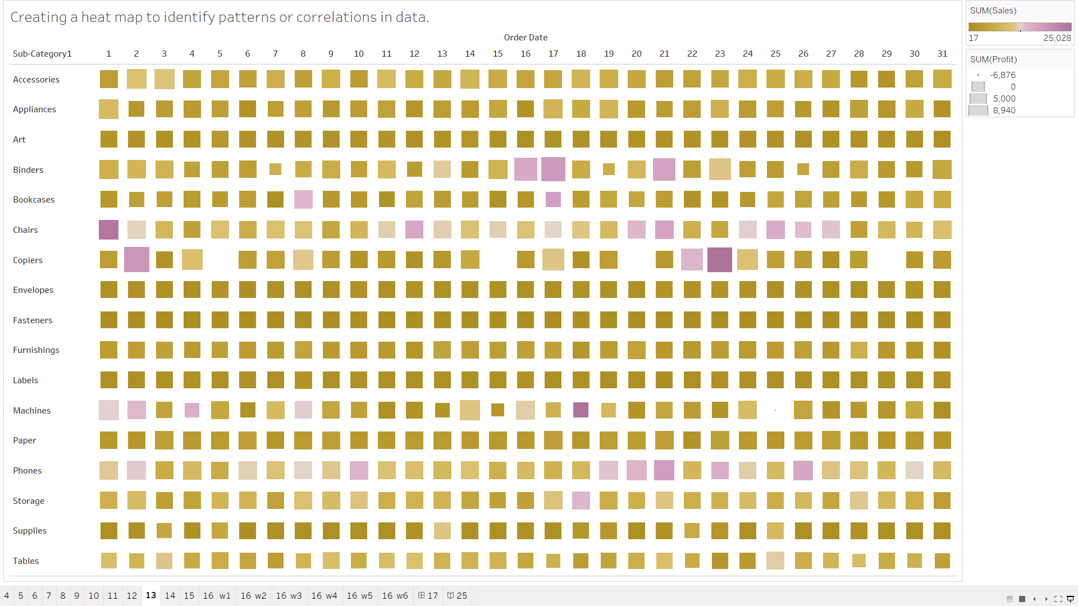

**Based on their profitability, various product subcategories are shown visually in this chart.**

* **Interpretation:** The size of each rectangle reflects the total profit made, and each rectangle indicates a sub-category within the data (e.g., Accessories, Phones, Binders).
* The color coding shows the spectrum of profits; yellow tones imply lower profitability, and darker green implies larger profit.
* **Data Filtering:** To guarantee that only profit information is displayed for each subcategory, the "SUM(Profit)" field has been added to the data.
* **Sorting:** Tableau automatically arranges the subcategories according to profit, making it possible to quickly see which subcategories have the greatest or least impact on profitability.

## 14. Implementing dual-axis charts to compare two metrics with different scales

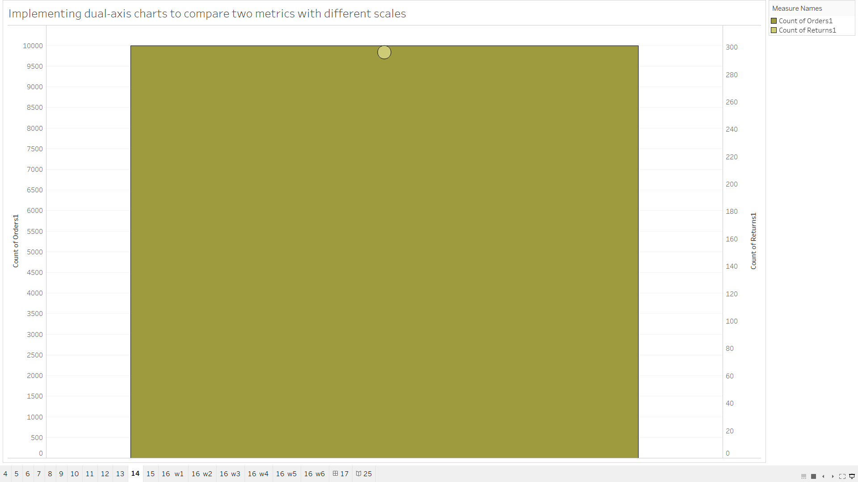

**Orders and Returns are two metrics with different scales that are compared in the first depiction using a dual-axis chart. The graph displays:**

* Order Count (9,994) plotted on the left.
* 296 is the count of returns on the right axis.
* Because it enables the comparison of two measurements with disparate ranges, this kind of graphic is useful. The dual-axis approach makes sure that both measurements are easily observable without being overpowering the reader because of the scale disparity.
* You most likely made use of Tableau's dual-axis capability for this visualization:
* Two measures were established by you: CNT(Orders) and CNT(Returns).
* Both metrics are shown on the same chart, with Orders on one axis and Returns on the other, by arranging them in different rows and synchronizing the axes.
* The difference between the two measurements is graphically highlighted by the huge orange circle.
* **Main Points of the Report:**
* Comparing various metrics on various scales is possible with dual-axis charts.
* The operational efficiency of this example is demonstrated by the notable difference between the number of orders (9,994) and returns (296).

## 15. Applying advanced calculations and functions for customized metrics.

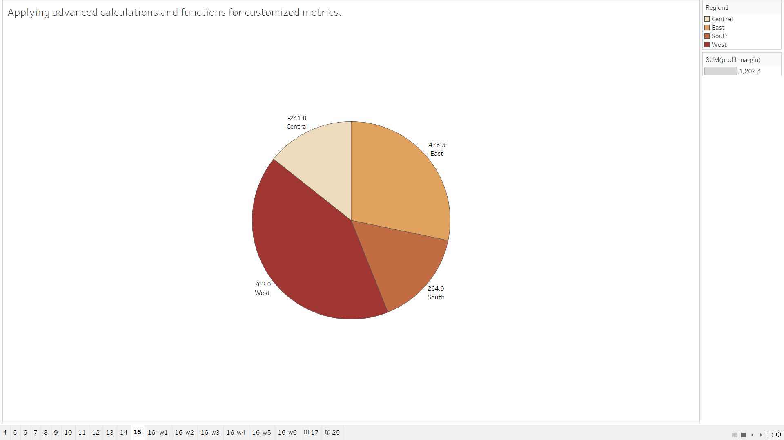

* **The profit margins for the Central, East, South, and West areas are displayed in a pie chart. This is the summary:**
* West: 703.0; Central: -241.8; East: 476.3; South: 264.9
* Profit margin overall: 1,202.4
* Advanced computations are used in this visualization, most likely to aggregate the profit margin by area using Tableau's computed fields. The most and least profitable regions are represented in the pie chart, which graphically divides the overall profit into regional divisions.
* **Steps taken:**
* **Profit Margin Calculation:** Possibly using a bespoke formula based on profit divided by sales, you calculated the profit margin.
* **Aggregating by Region:** You can examine how each region contributes to the total by using the SUM function and separating the data by region.
* The Central region's negative profit is displayed in the pie chart, which is helpful in emphasizing regions that require development.
* **Main Points of the Report:**
* Customized indicators, including profit margin by location, are provided through the application of sophisticated computations.
* The geographical performance is seen in the pie chart, where the West is the most profitable region while the Central region is losing money.

## 16. Create minimum six worksheets for data visualization in Tableau using Sales Dataset.

**Worksheet-1**

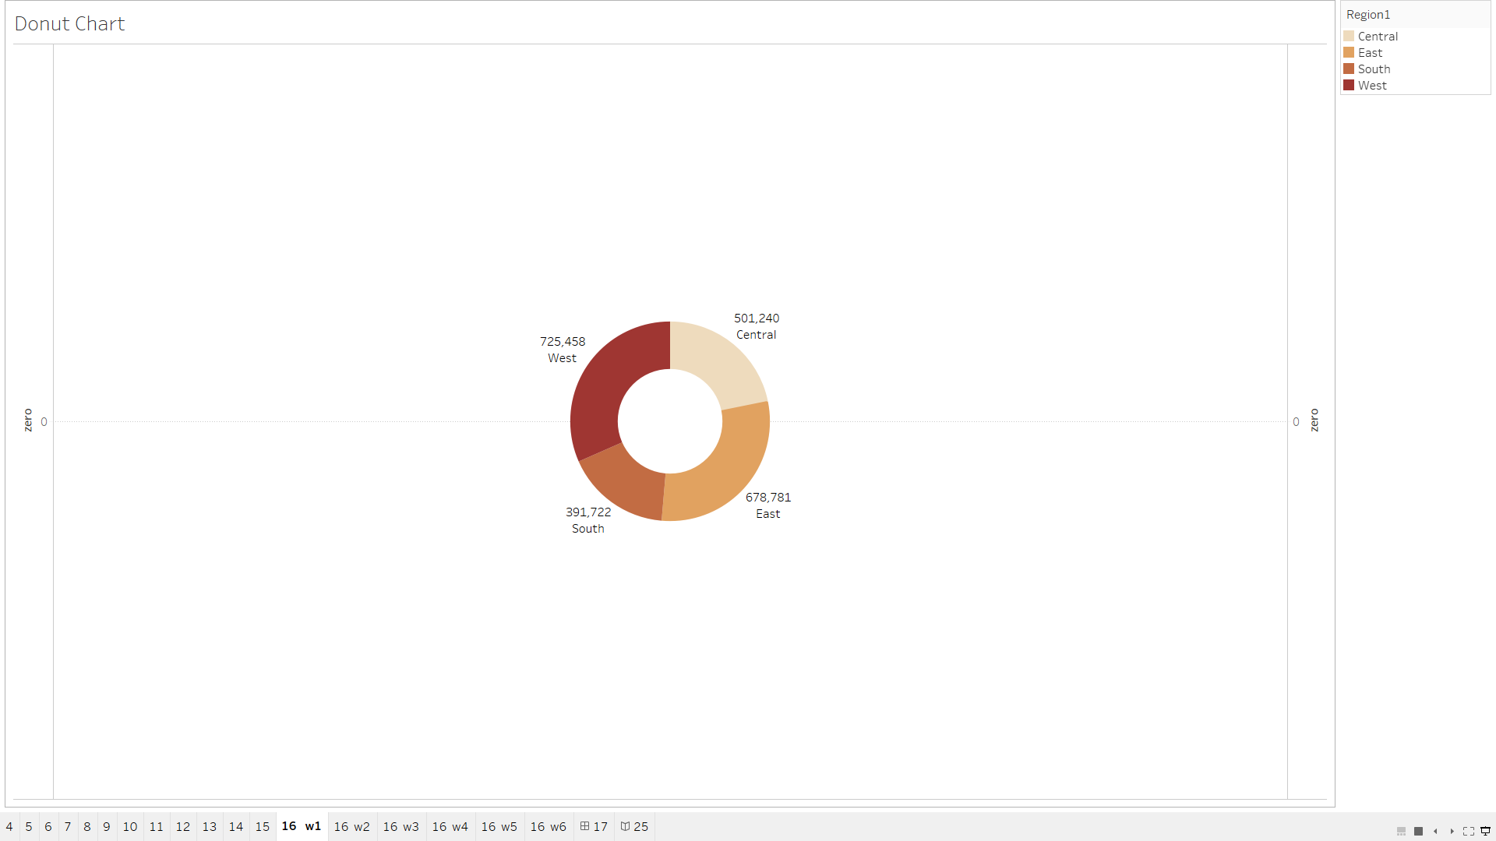

* This image shows a Tableau dashboard with a donut chart visualizing sales data by region. The chart displays the total sales for each region (Central, West, South, East) using different colors.

**Worksheet-2**

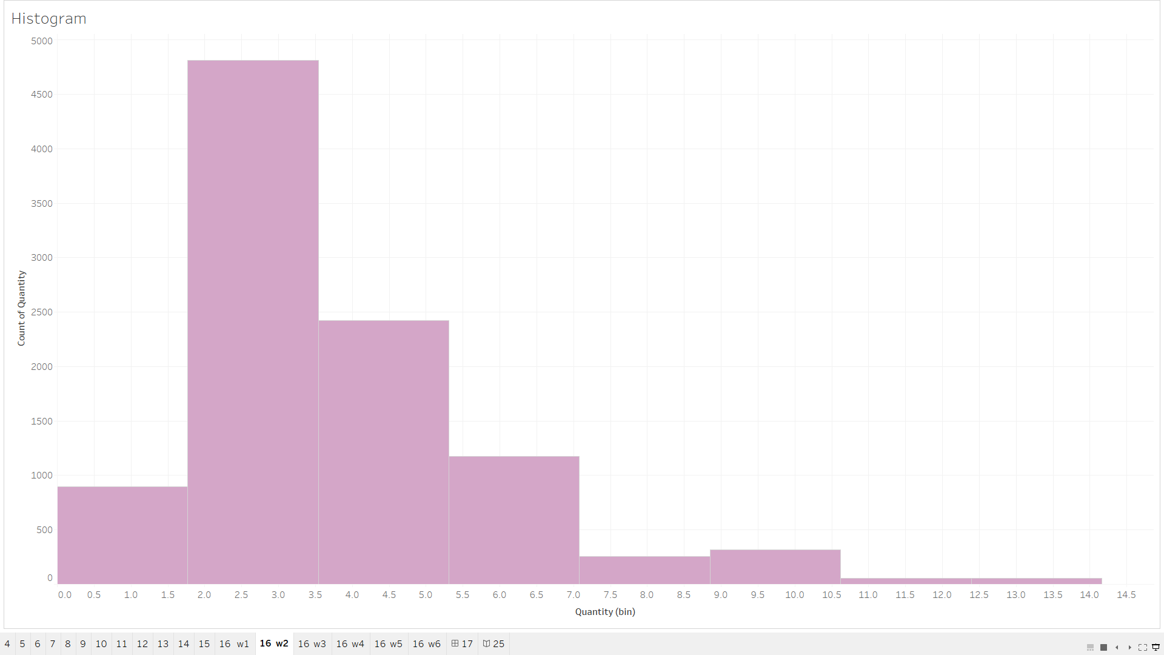

* This image shows a Tableau dashboard with a histogram visualizing the distribution of order quantities. The x-axis represents the quantity range (0-15), and the y-axis represents the count of orders within each range. The histogram shows that most orders have a quantity between 0 and 5, with decreasing frequency for higher quantity ranges.

**Worksheet-3**

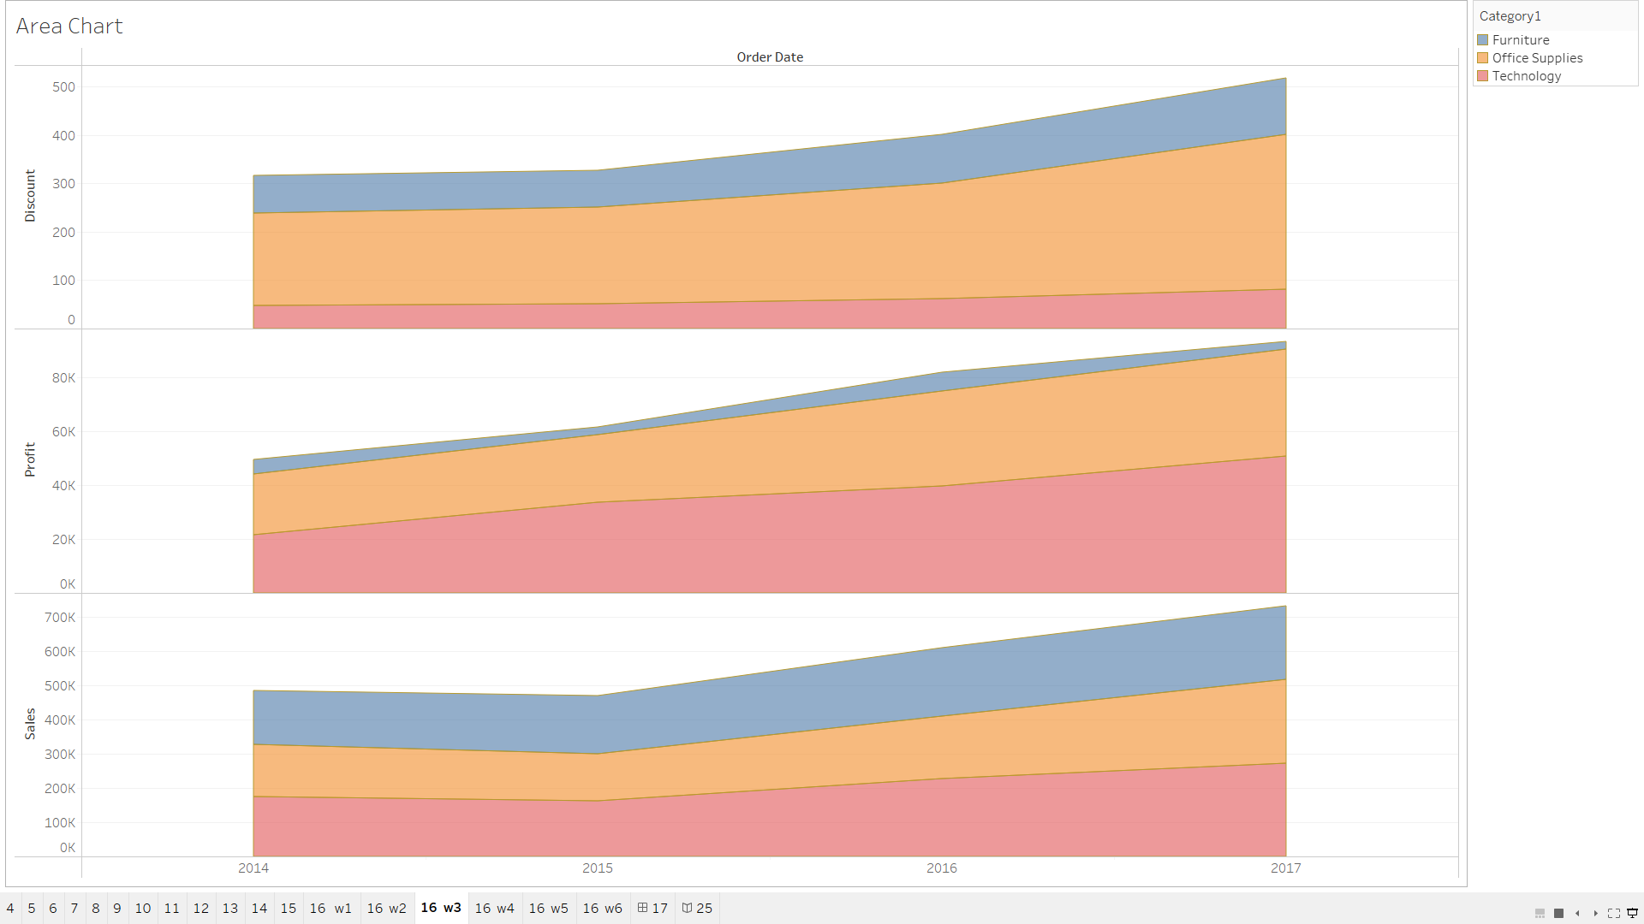

* This image shows a Tableau dashboard with three area charts visualizing sales, profit, and discount trends over time. The x-axis represents the order date (by year), and the y-axis represents the sum of sales, profit, and discount. The charts are stacked to show the contribution of each category (Furniture, Office Supplies, Technology) to the total sales, profit, and discount.

**Worksheet-4**

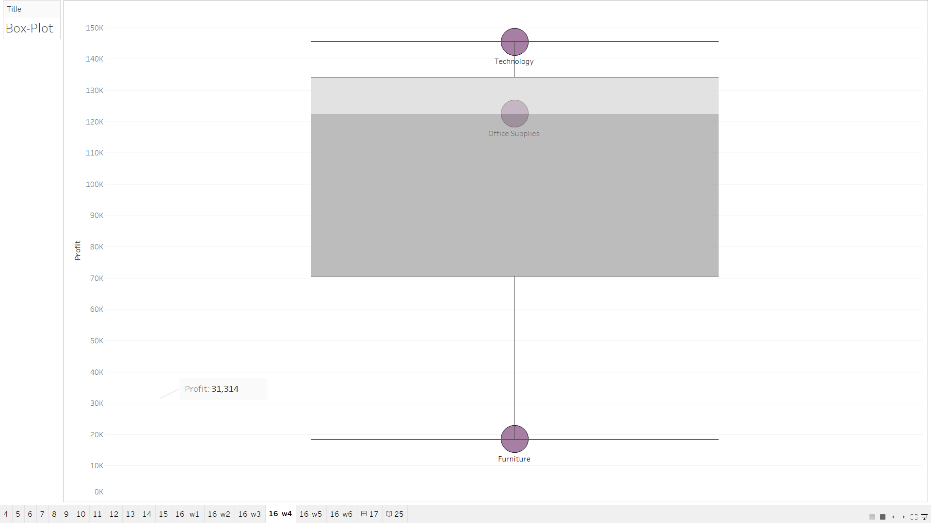

* This image shows a Tableau dashboard with a box plot visualizing the distribution of profit by category. The x-axis represents the category (Furniture, Office Supplies, Technology), and the y-axis represents the profit. The box plot shows the median profit, interquartile range, and potential outliers for each category, providing insights into the profit variability within each category.

**Worksheet-5**

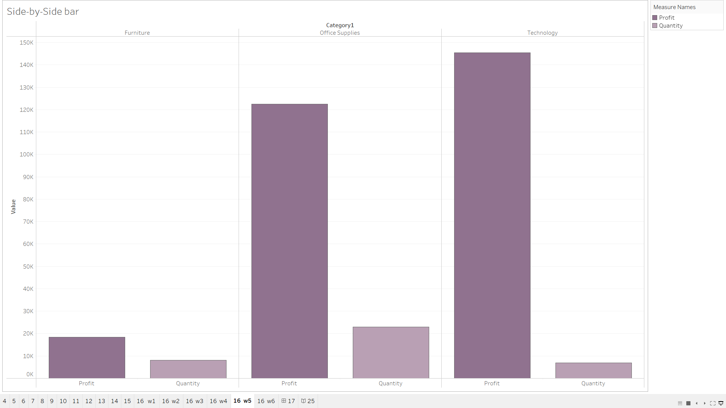

* This image shows a Tableau dashboard with three side-by-side bar charts comparing profit and quantity across different categories (Furniture, Office Supplies, Technology). The x-axis represents the category, and the y-axis represents the sum of profit and quantity. The charts provide insights into the relative profit and quantity levels for each category.

**Worksheet-6**

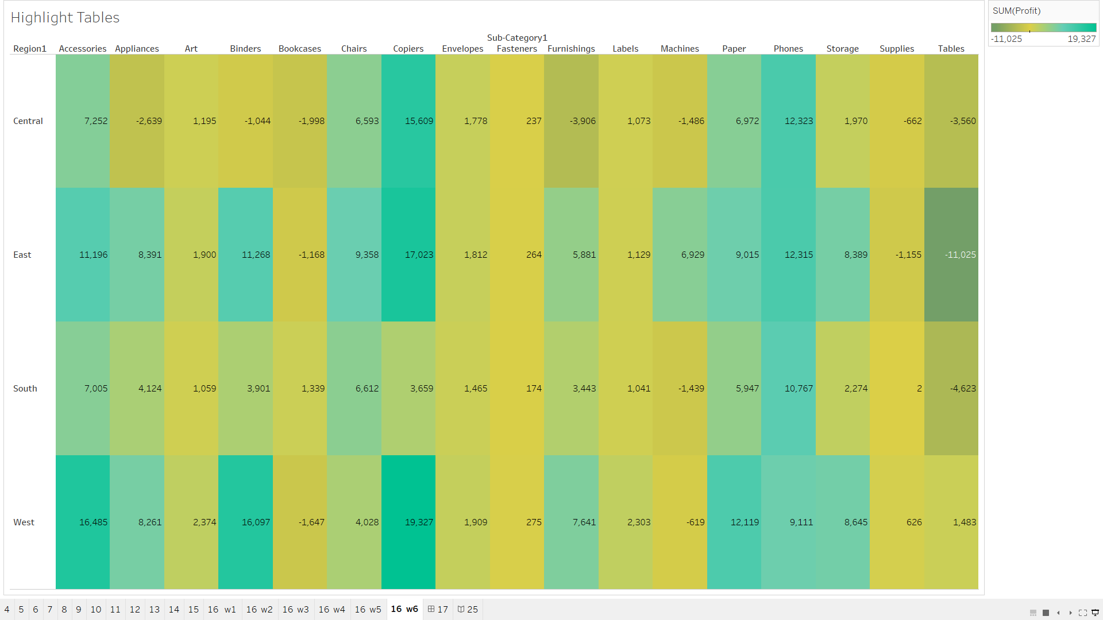

* This image shows a Tableau dashboard with a heatmap visualizing the profit for each sub-category within different regions. The x-axis represents the sub-categories, the y-axis represents the regions, and the color intensity represents the profit level. The heatmap helps identify sub-categories with high or low profit levels in each region.

## 17. Designing a comprehensive dashboard with multiple visualizations for Sale Dataset.

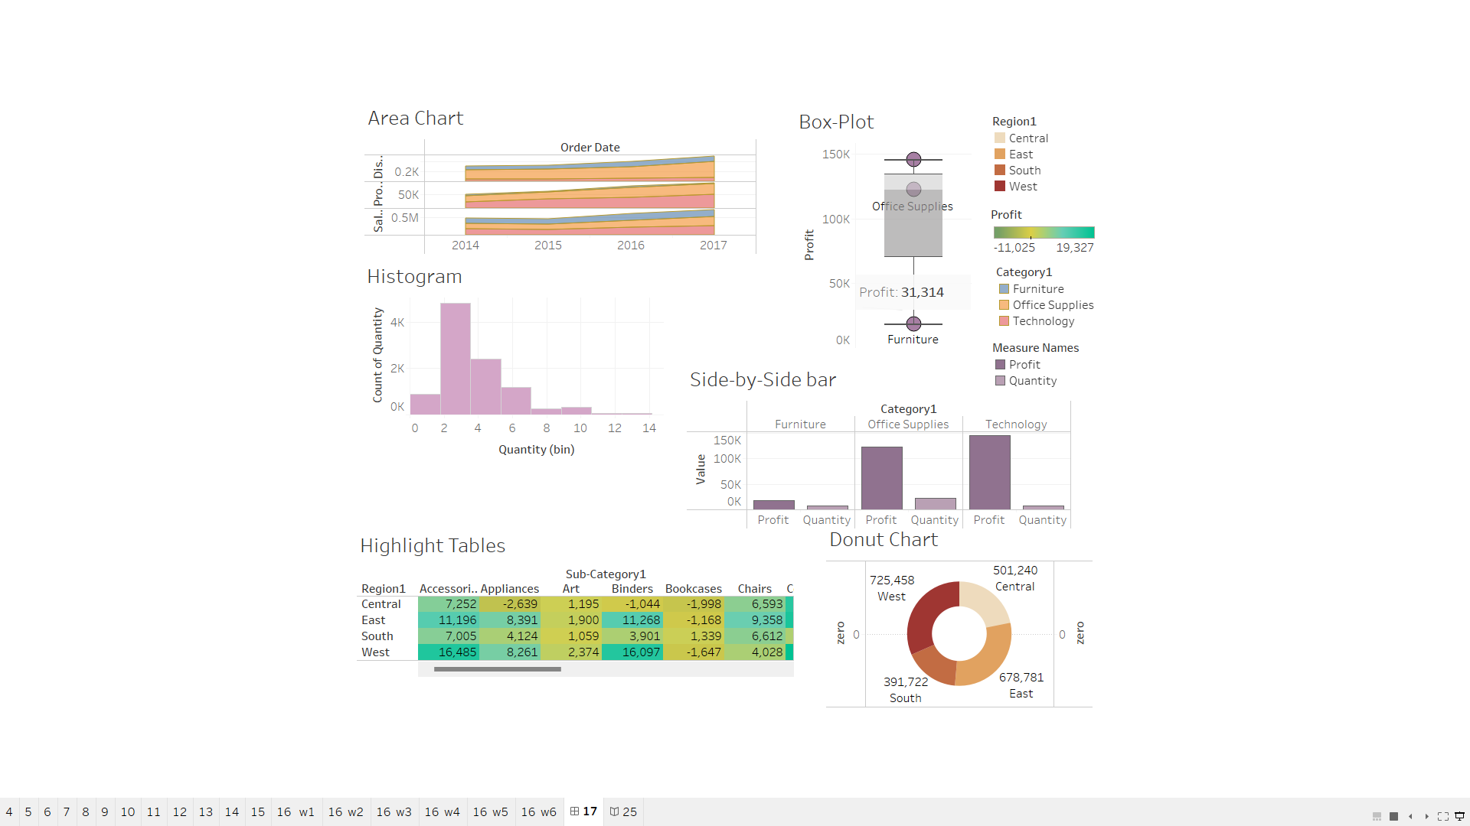

* This image shows the dashboard of different worksheets.

## 18. Prepare a census dataset (data must be actual as per Gov portal), generate maps geographical, Bar Chart, Pie Chart, Bubble Chart visualization using Tableau and Create a Complete Dashboard.

Worksheet-1

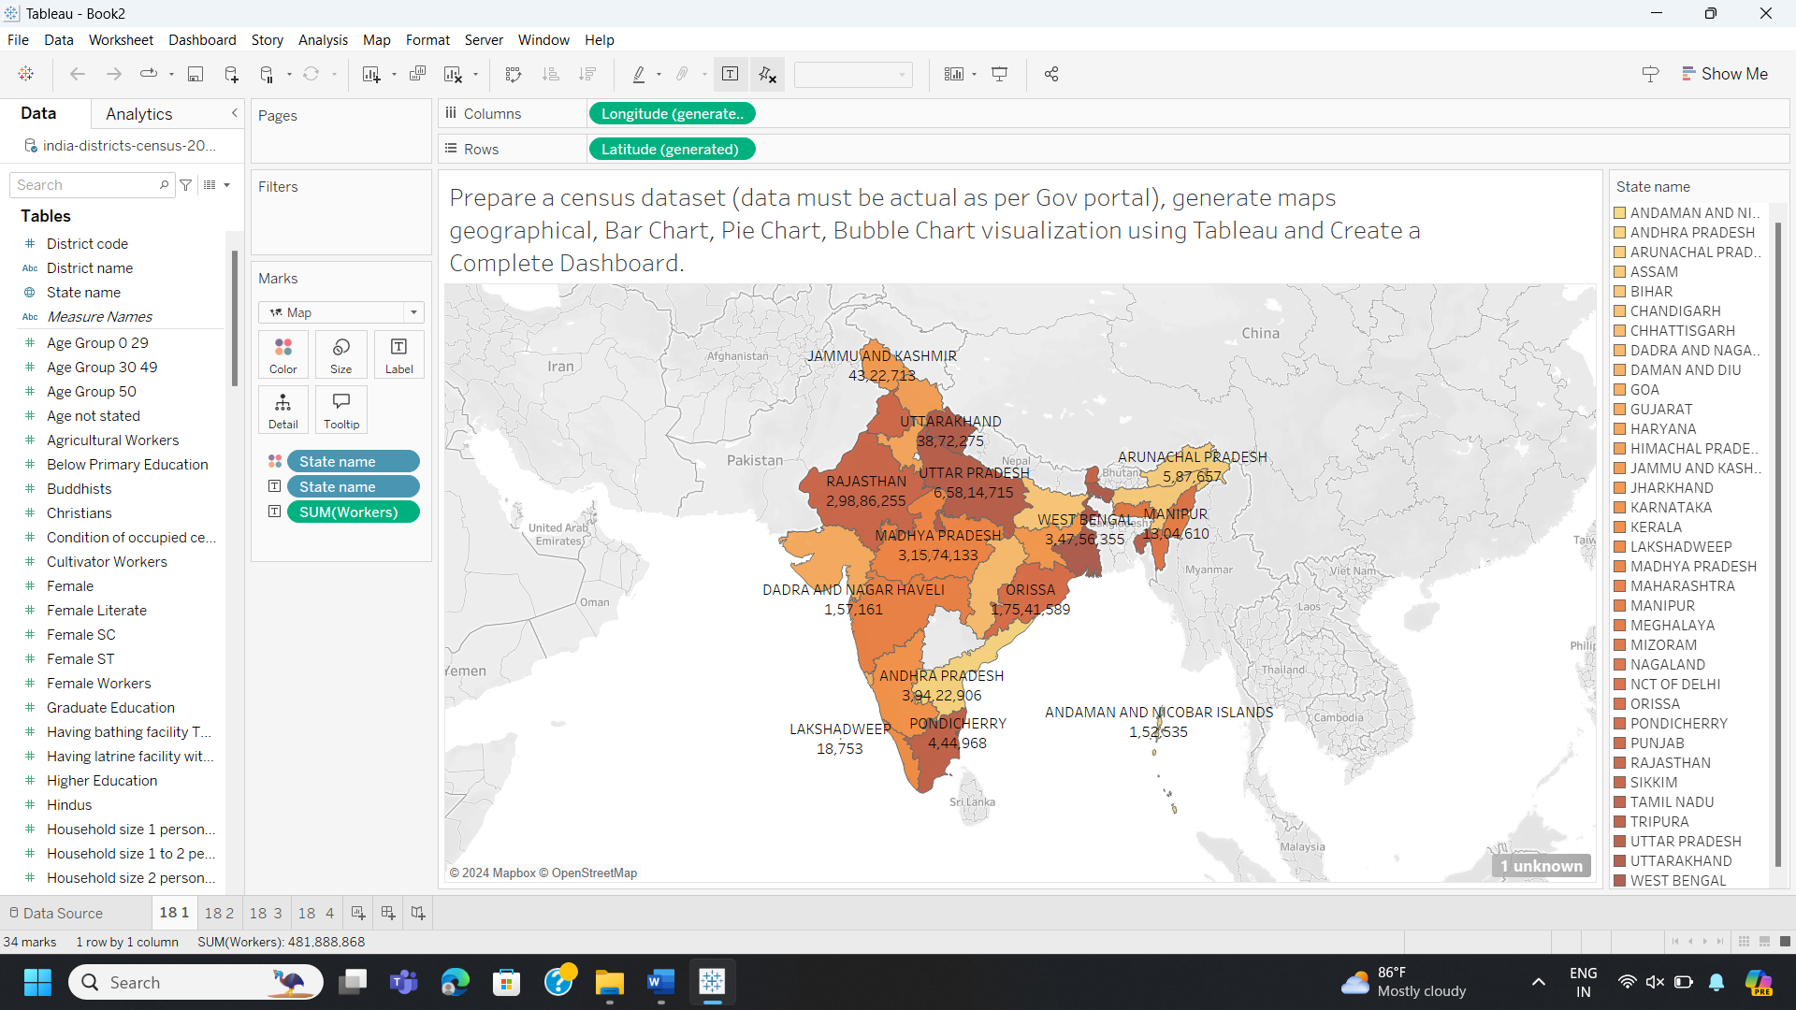

* This image shows a Tableau dashboard with a map of India visualizing the distribution of a specific metric (e.g., population, literacy rate) across different districts. The map uses color intensity to represent the variation in the metric values, providing a visual understanding of spatial patterns and regional differences.

**Worksheet-2**

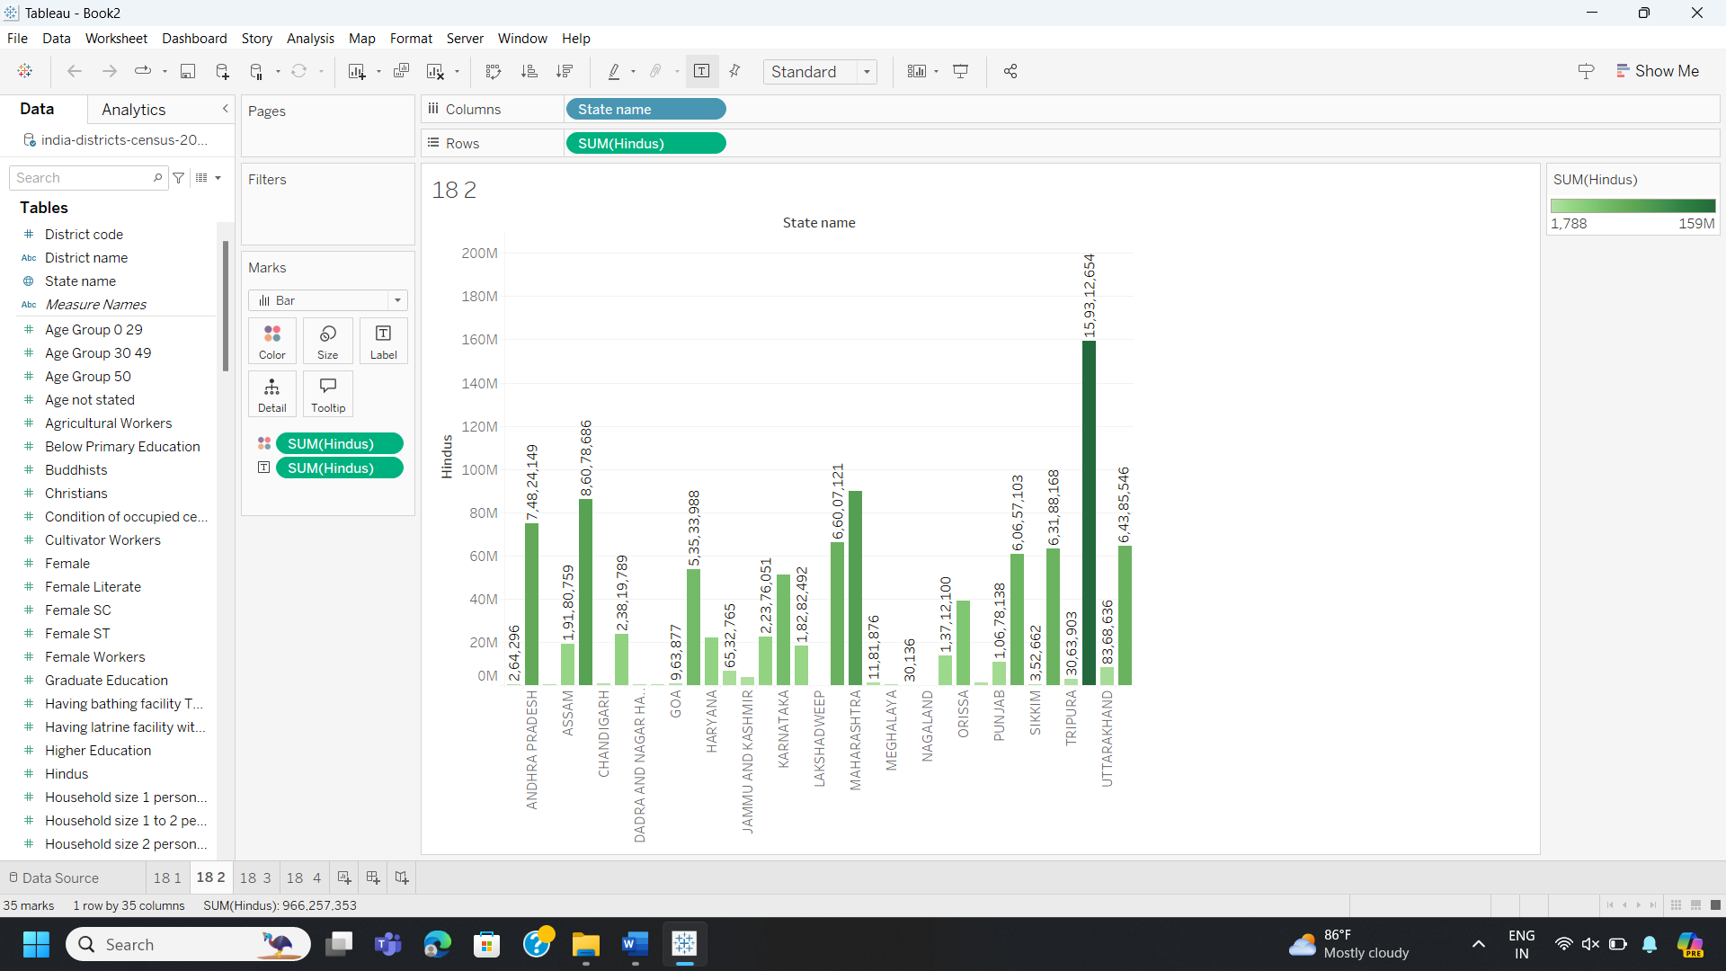

* This image shows a Tableau dashboard with a bar chart visualizing the number of Hindus across different states in India. The x-axis represents the state names, and the y-axis represents the sum of the Hindu population. The chart highlights the states with the highest and lowest Hindu populations.

**Worksheet-3**

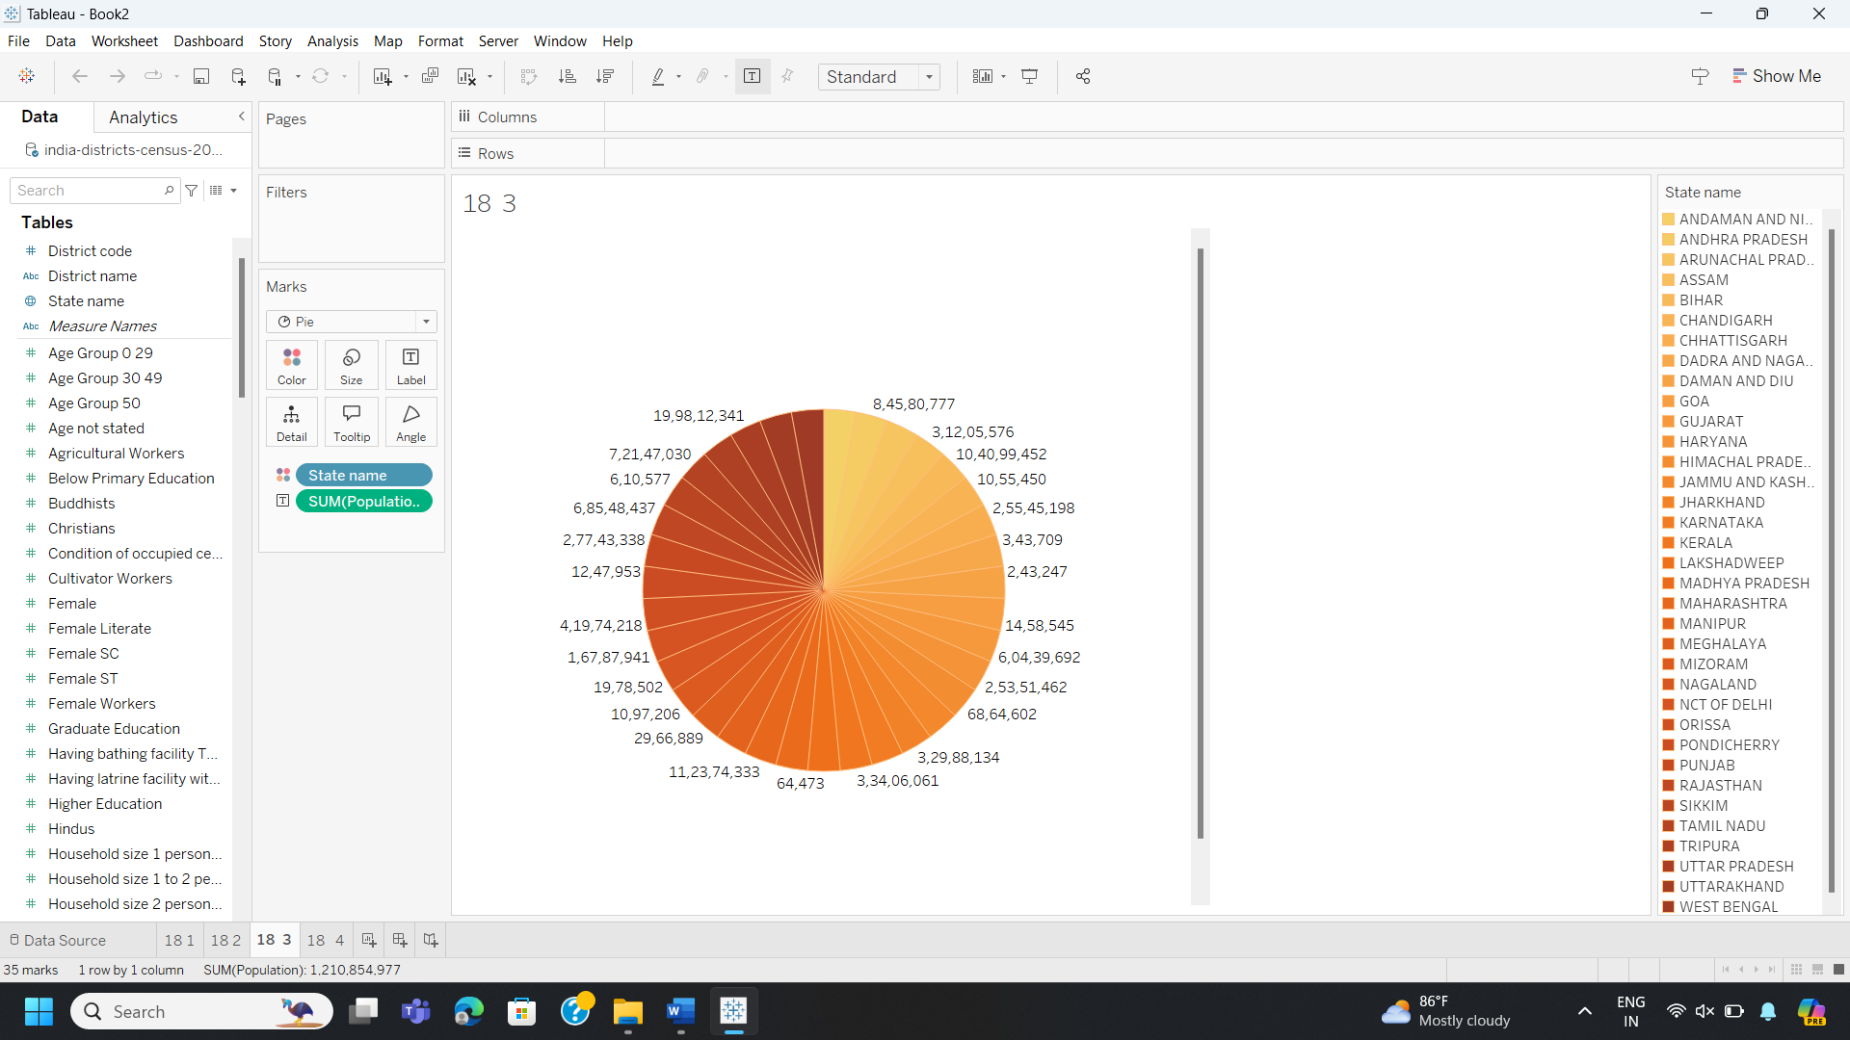

* This image shows a Tableau dashboard with a pie chart visualizing the distribution of the population across different age groups in India. The chart displays the percentage of the population in each age group, providing insights into the age structure of the Indian population.

**Worksheet-4**

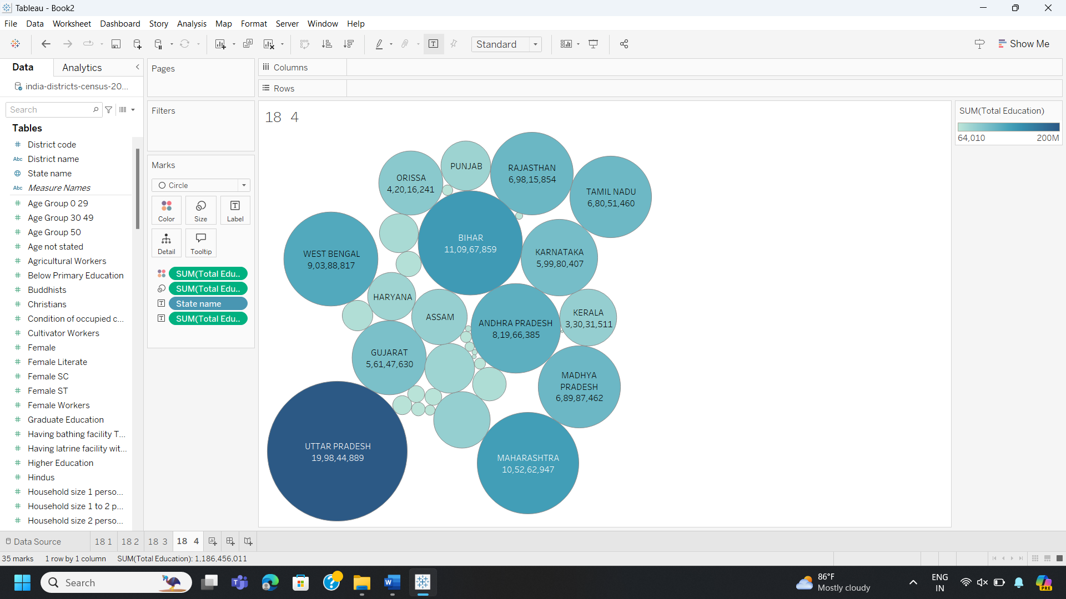

* This image shows a Tableau dashboard with a bubble chart visualizing the total education level across different states in India. The size of each bubble represents the total education level in that state, and the color represents the state name. The chart helps identify states with higher or lower education levels.

**Dashboard:**

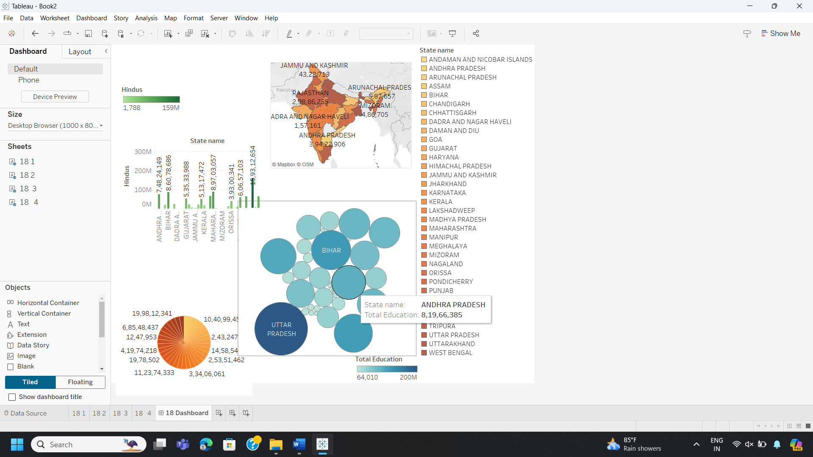

* This image shows the dashboard of different worksheets.

## 19. Prepare a City wise Air Quality Index dataset and generate visualization using Tableau. Try to use maximum functions available in Tableau 1. Colour 2. Label 3. Filter 4. Sorting 5. Swap Row Column 6. Size of objects.

**1. Colour**

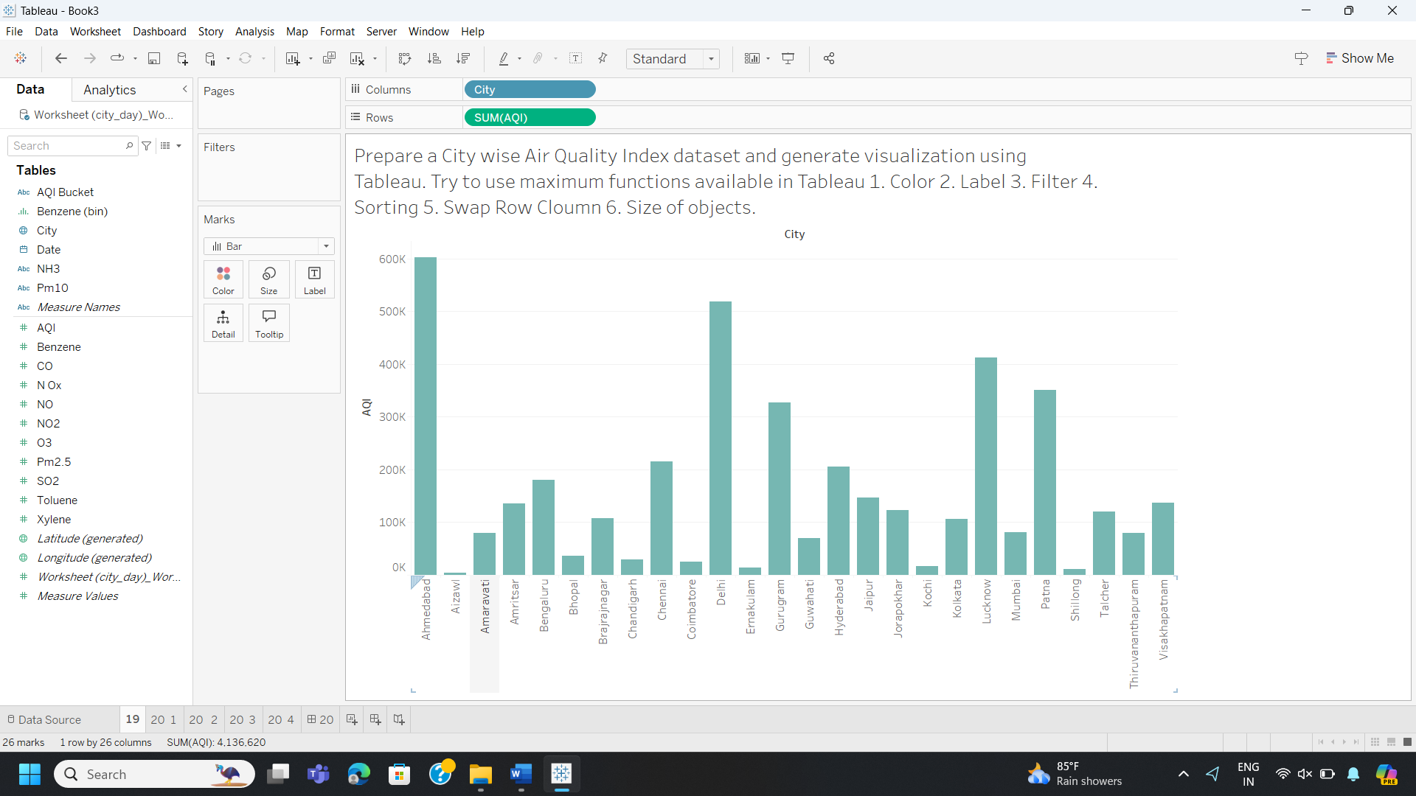

**2. Label**

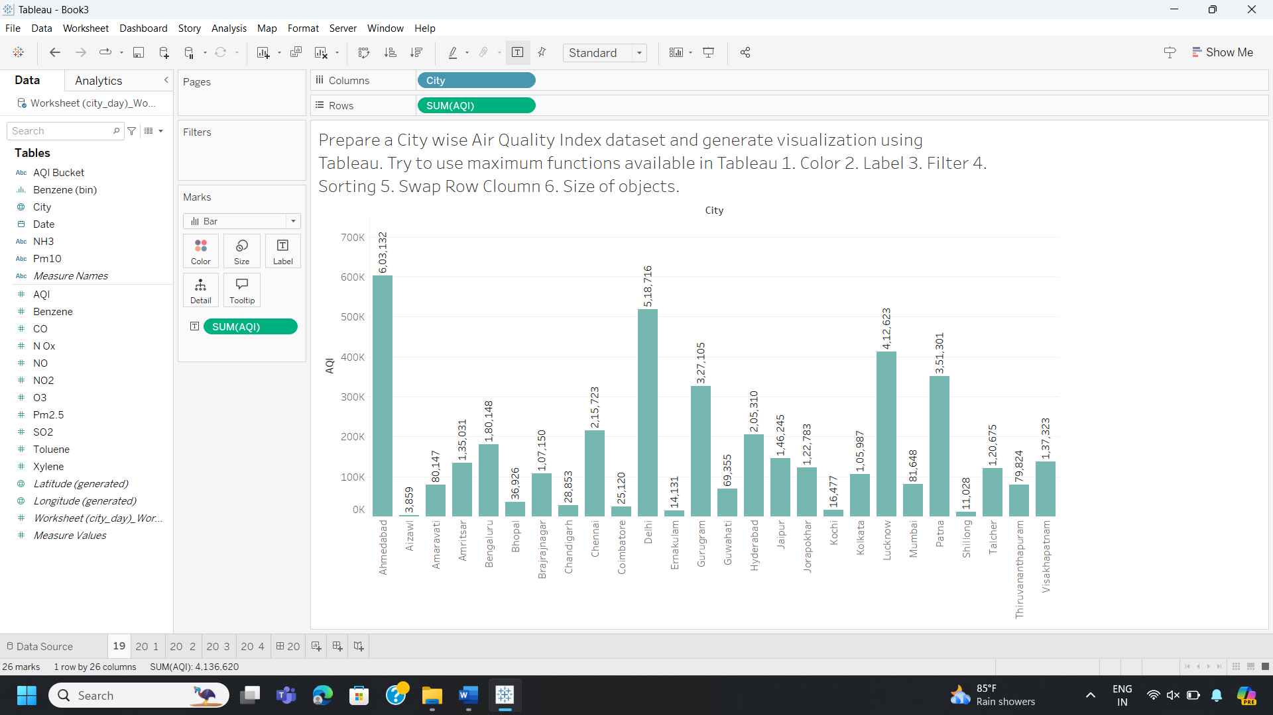

**3. Filter**

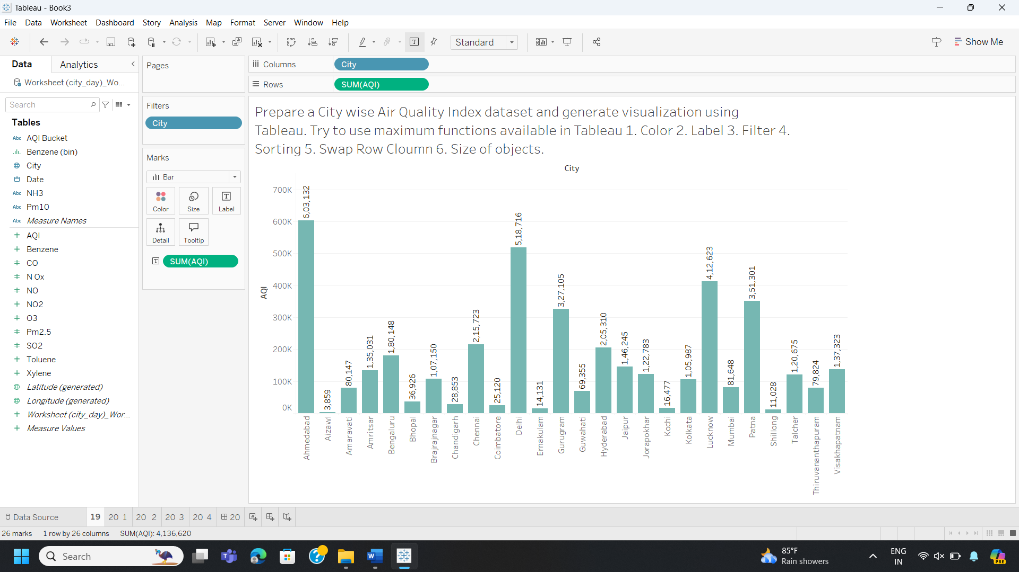

**4. Sorting**

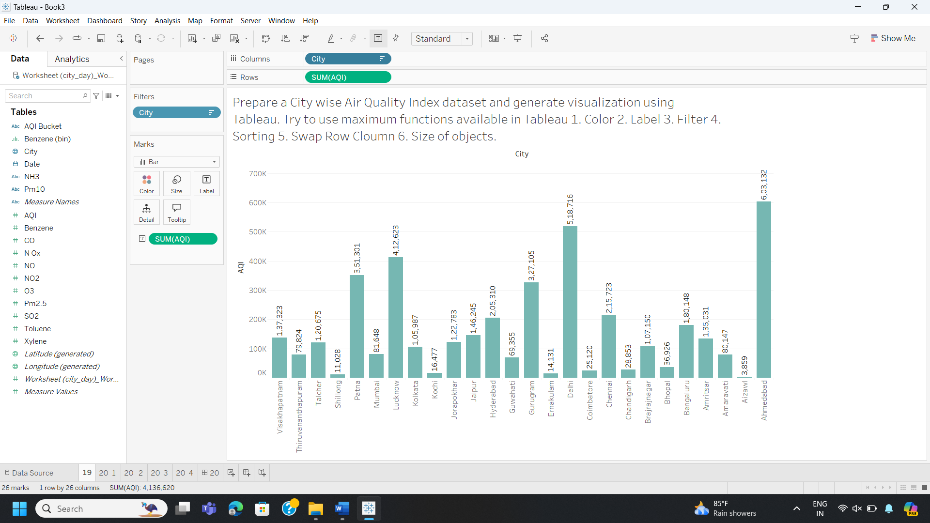

**5. Swap Rows and Columns**

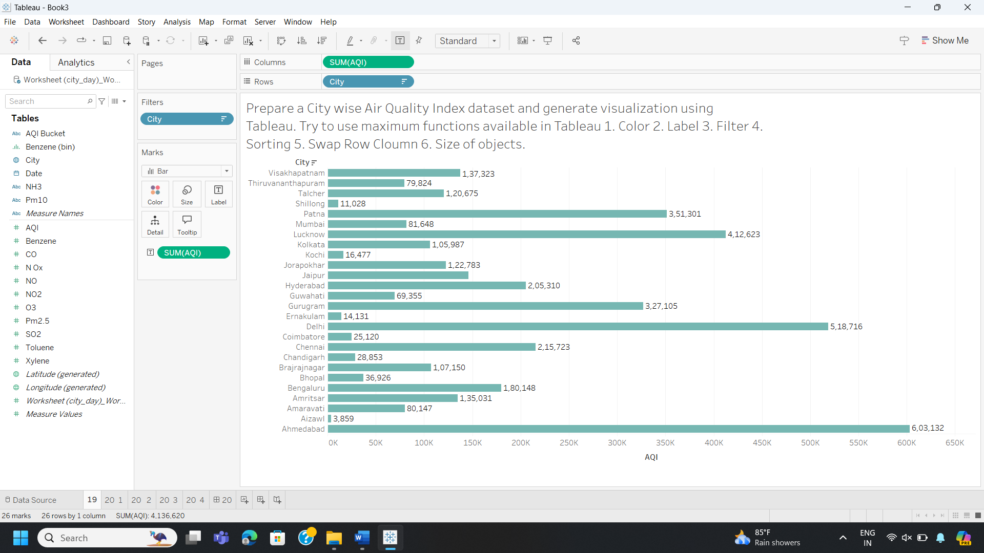

**6. Size of Objects**

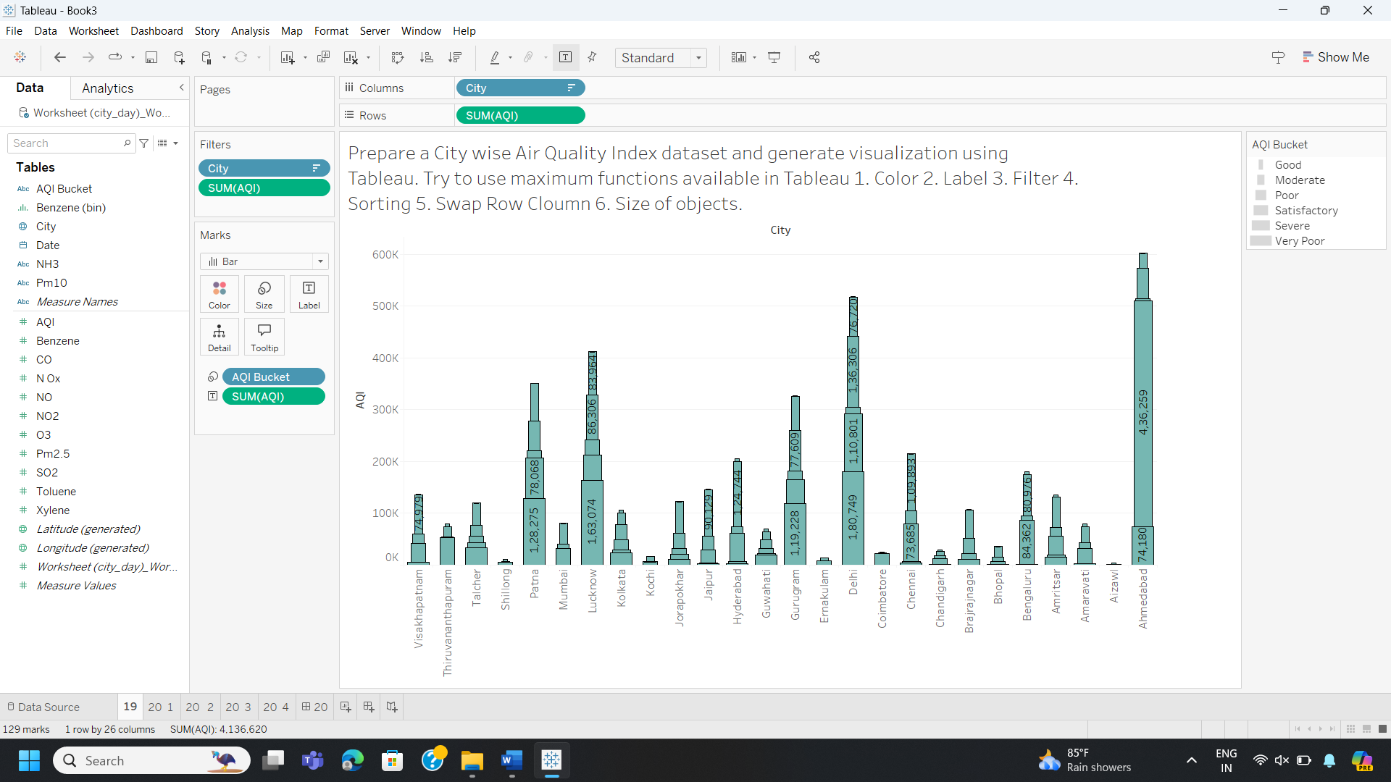

* The Tableau dashboard effectively utilizes various visualization techniques to enhance the understanding of air quality data. Color coding is used to visually represent different AQI levels, providing an immediate indication of air quality conditions. Labels are added to identify each city and its corresponding AQI value, making the data more accessible and understandable. Filters allow users to select specific cities or AQI ranges, enabling targeted analysis. Sorting functionality enables the bars to be arranged in ascending or descending order based on AQI values, facilitating easy comparison. The ability to swap rows and columns provides flexibility in organizing the data presentation. Lastly, the size of the objects can be adjusted to visually emphasize cities with higher or lower AQI values, drawing attention to areas of concern.

## 20. Create a Dashboard for AQI Visualizations.

Worksheet-1

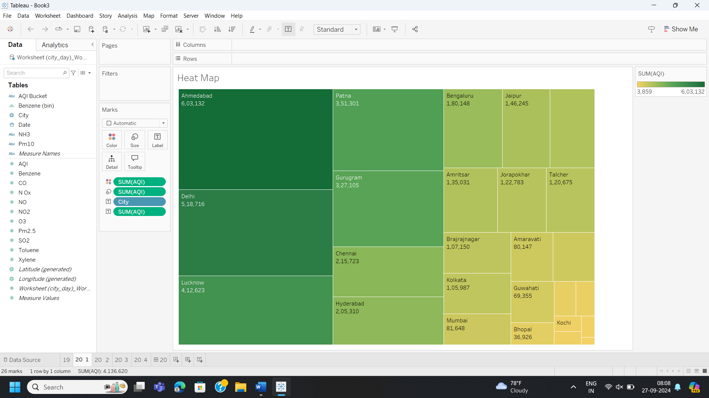

* This image shows a heat map visualization in a tool, likely Tableau. The heat map displays data for various cities, with different colors representing varying values of a metric, likely air quality. The cities are organized into a grid, with darker colors indicating higher values of the metric. The x-axis shows the cities, while the y-axis likely represents a time dimension or another relevant variable.

Worksheet-2

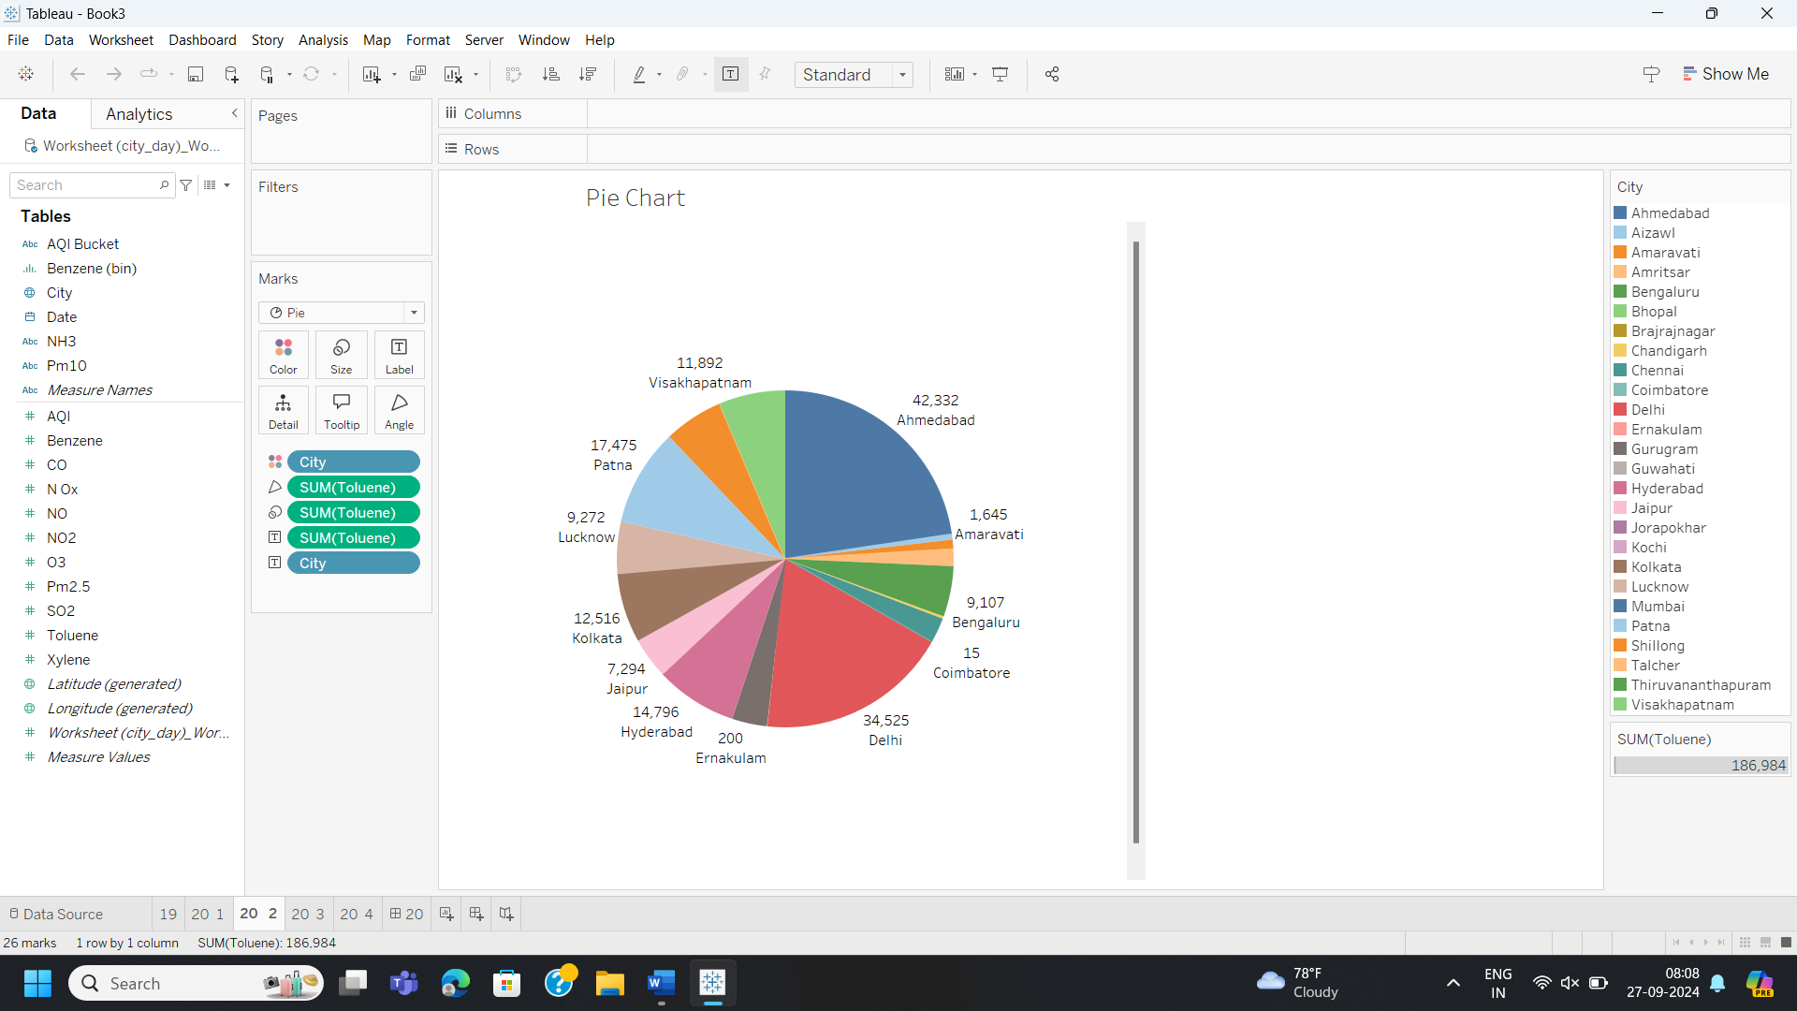

* This image shows a pie chart visualization in a tool, likely Tableau. The pie chart displays data for various cities, with each slice representing a different city and the size of the slice corresponding to the value of a metric, likely air quality. The cities are labeled with their names and the corresponding values of the metric are displayed. The chart shows that Delhi has the highest value of the metric, followed by Ahmedabad and Visakhapatnam.

Worksheet-3

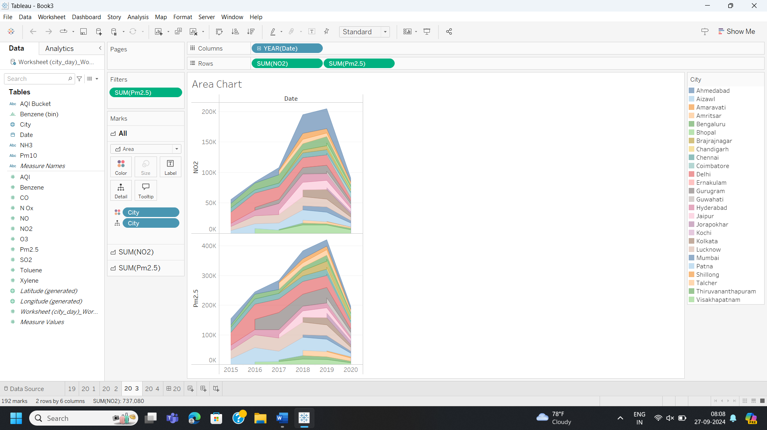

* This image shows an area chart visualization in a tool, likely Tableau. The area chart displays data for various cities over time, with different colors representing different cities and the area of each section representing the value of a metric, likely air quality. The x-axis shows the time period, while the y-axis shows the value of the metric. The chart shows the trend of air quality for each city over time, with some cities showing an increasing trend and others showing a decreasing trend.

Worksheet-4

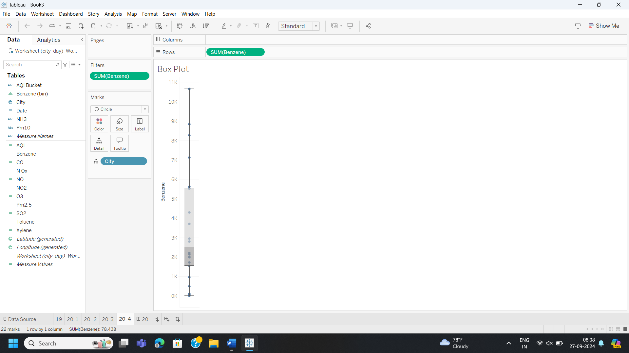

* This image shows a box plot visualization in a tool, likely Tableau. The box plot displays data for various cities, with each box representing a different city and the position of the box indicating the distribution of a metric, likely air quality. The x-axis shows the cities, while the y-axis shows the value of the metric. The chart shows the median value of the metric for each city, as well as the interquartile range and the minimum and maximum values.

Dashboard

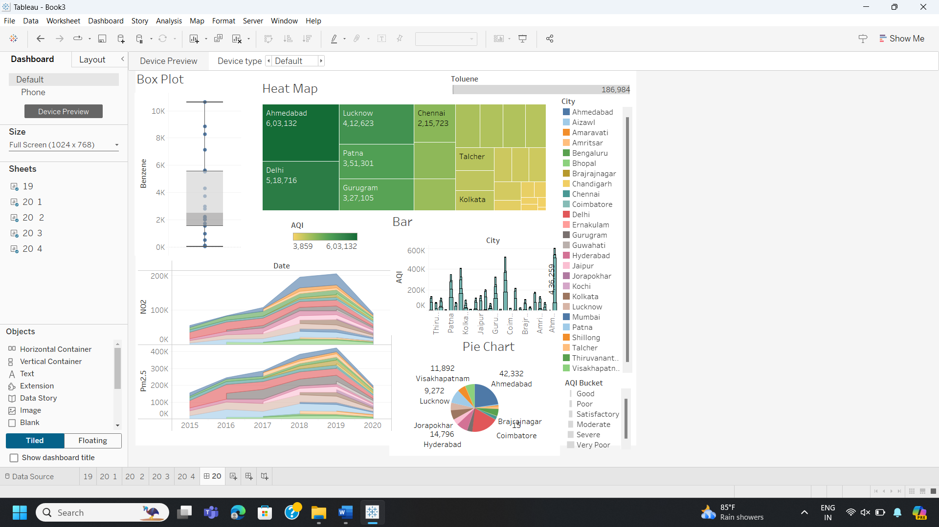

* This image shows the dashboard of different AQI visualizations worksheets.

## 21. Apply BG Color, Float, Add filter, Add links/Image, Add Download button, Add navigations, on your AQI Dashboard.

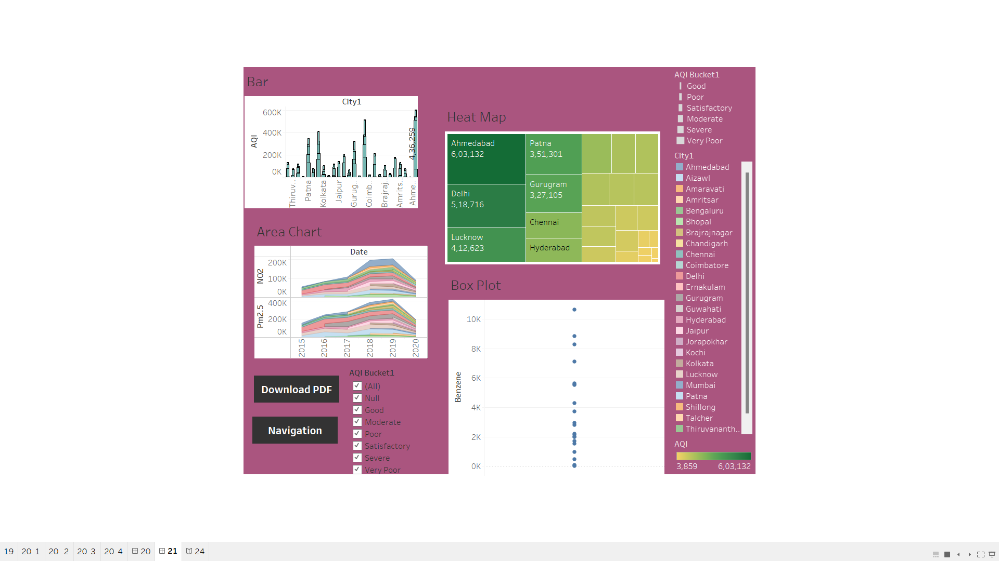

* This dashboard presents an overview of air quality metrics across various Indian cities using multiple visual representations. Below is a breakdown of each section:

**Bar Chart (Top Left):** Displays the Air Quality Index (AQI) for different cities.Highlights major cities with their AQI values shown as vertical bars.

**Heat Map (Top Right):** Visualizes AQI values for selected cities with color-coded tiles.The color intensity represents the AQI level, where darker green indicates higher AQI readings.

**Area Chart (Bottom Left):** Shows trends over time for pollutant levels such as NO2 and PM2.5 from 2015 to 2020.Each layer in the chart represents the concentration of pollutants over the given period.

**Box Plot (Bottom Right):**Illustrates the distribution of Benzene levels across different locations.Data points indicate outliers or specific values for Benzene concentrations.

**Legend (Right Side):** Provides a reference for interpreting the AQI buckets, classifying AQI into categories such as Good, Moderate, Poor, etc.Lists city names with corresponding colors used in the visualizations.

**Controls and Options (Bottom Left):** Buttons to download a PDF of the report or navigate the dashboard.Filters for selecting AQI categories to customize the displayed data.

**Summary:** This dashboard offers an interactive tool for understanding air quality trends and comparisons among major cities in India, helping to identify areas with higher pollution levels and track changes over time.

## 22. Creating a data story on census dataset using Tableau's story features.

## 

This Tableau dashboard visualizes census data, focusing on the distribution of Hindus across different states in India. The visualization includes a bar chart showing the Hindu population in each state, a geographical heat map highlighting the population densities, and a bubble chart emphasizing total education levels in prominent regions like Uttar Pradesh and Bihar. Additional elements, such as a pie chart, provide a breakdown of populations across key states, offering a multidimensional perspective on the data.

## 23. Designing annotations and add captions to enhance your data story.

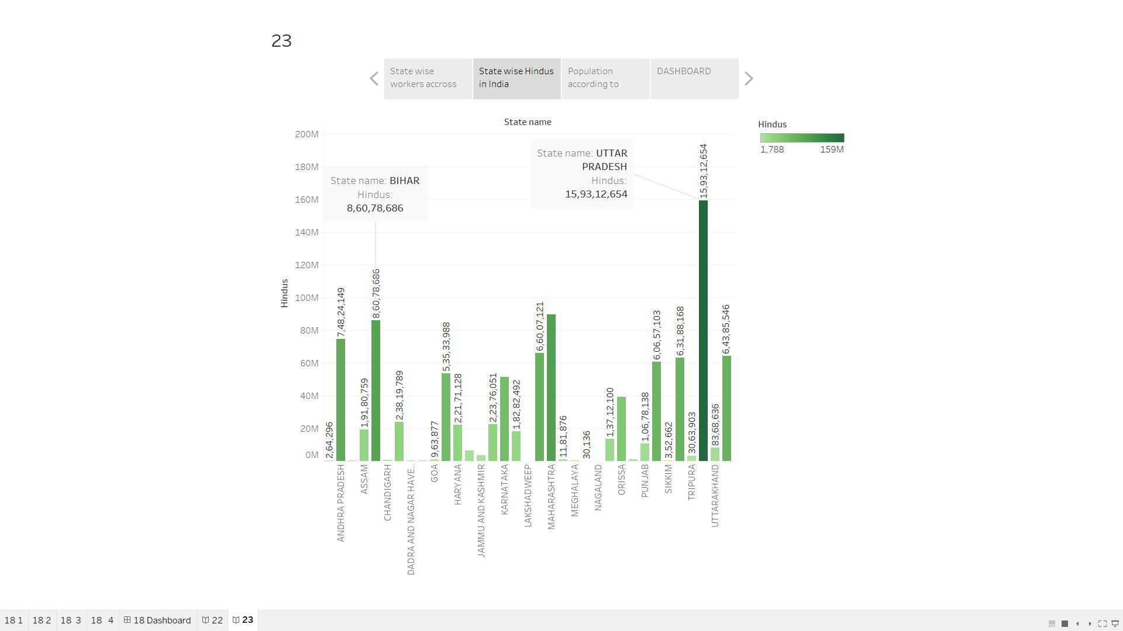

This Tableau dashboard provides a detailed analysis of India's census data with a specific focus on Hindu population distribution and education levels across states. Annotations highlight significant insights, such as Uttar Pradesh being the most populous state with over 159 million Hindus, marked by a dominant bubble in the chart. The heat map is captioned to emphasize areas of higher density, like Bihar and Tamil Nadu, aiding in comparative analysis. A pie chart complements this by showing proportional population shares of major states, with captions to explain disparities. These elements ensure clarity and guide viewers through the data narrative.

## 24. Create a Data Story for City wise Air Quality Index data.

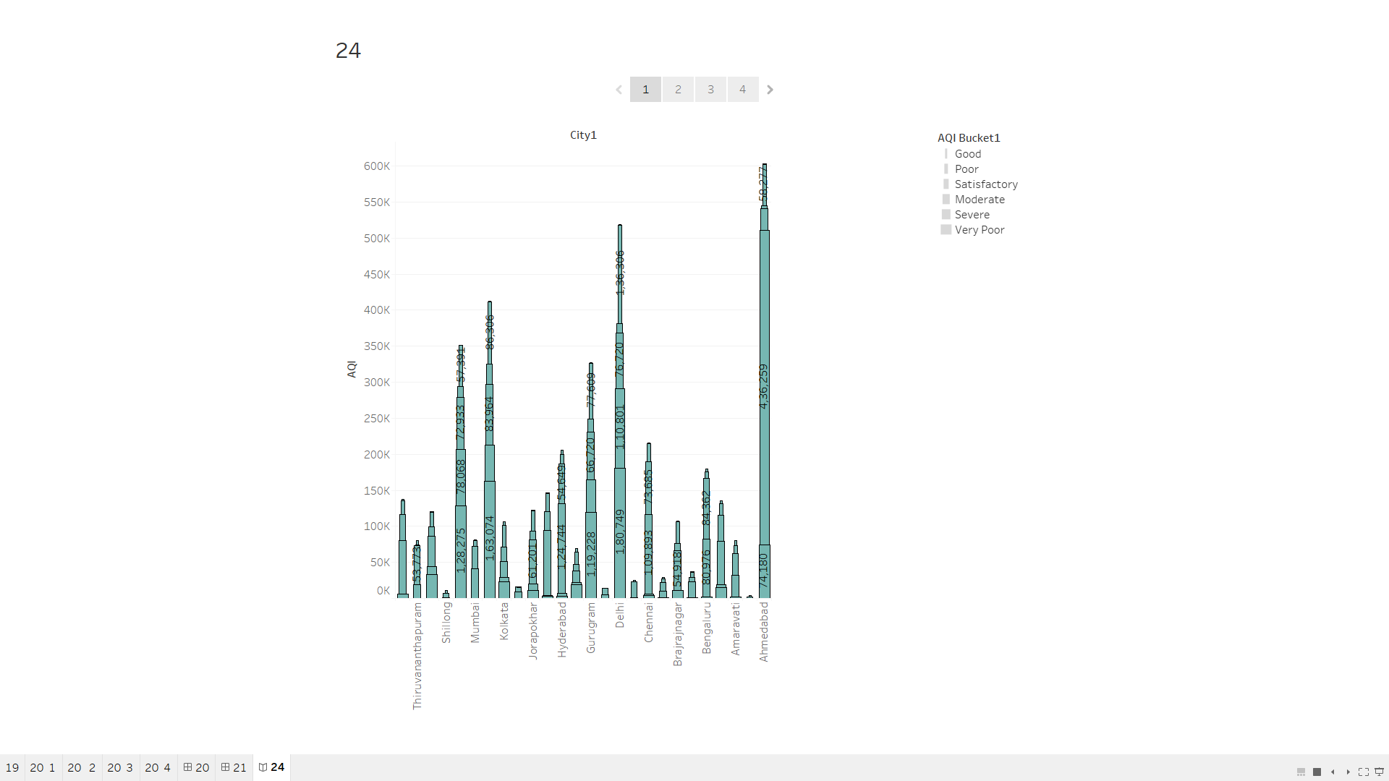

This story likely aims to provide an analytical overview of air quality across different cities to identify pollution levels, compare air quality categories, and reveal critical pollution data for decision-makers or researchers. Each graph in the story adds a layer of understanding to the AQI dataset by focusing on different aspects such as city-wise analysis, distribution spread, and pollutant trends.

## 25. Create a Data Story for Sale Data.

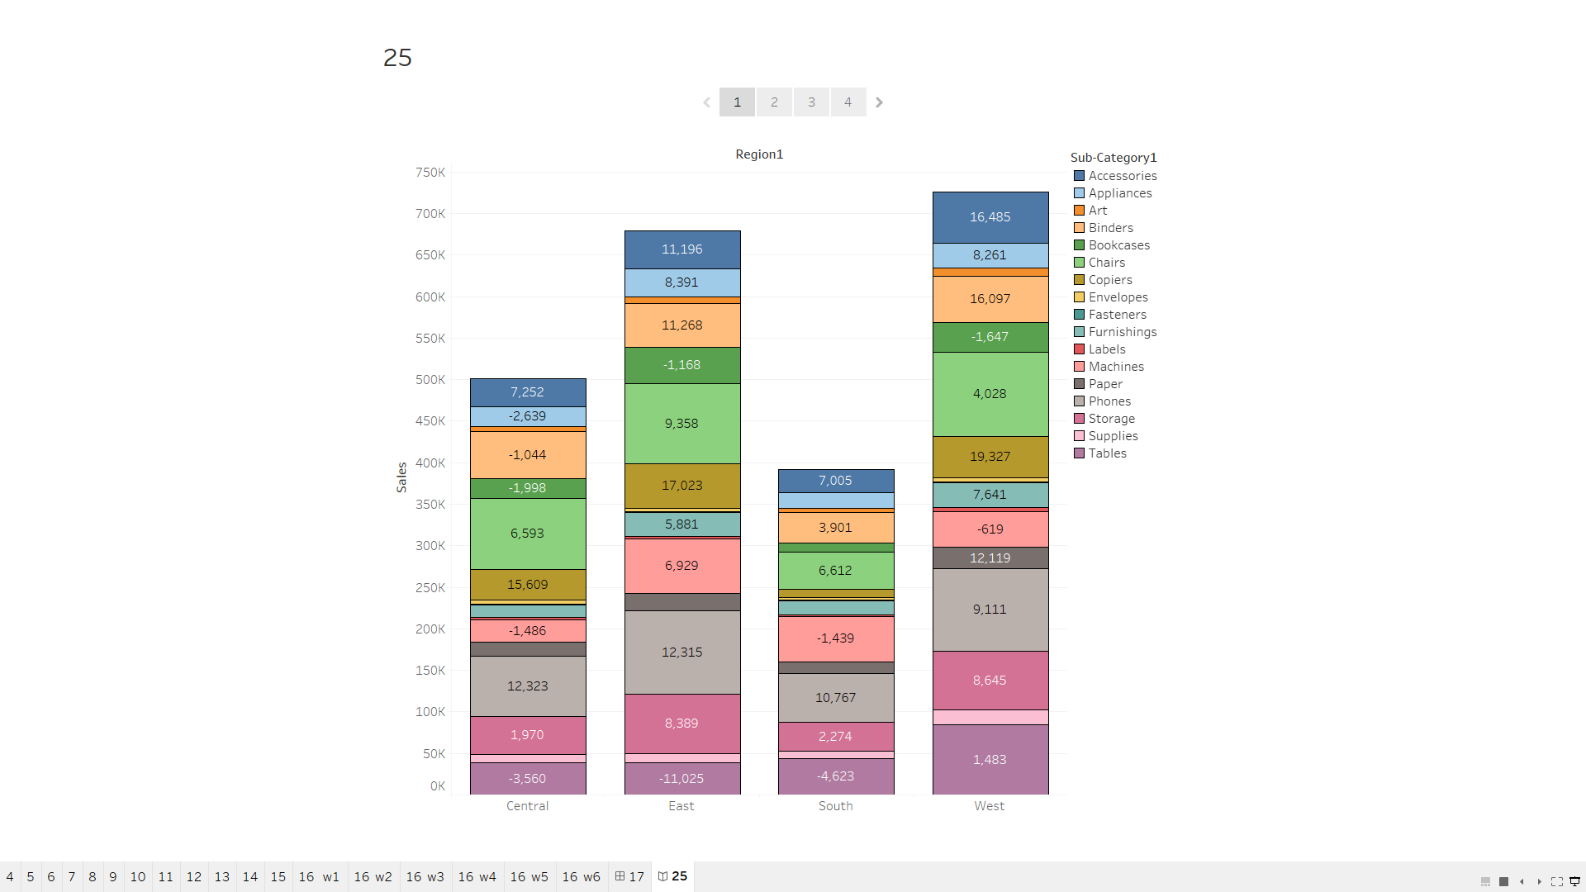

This Tableau data story highlights various approaches to visualizing business and sales data. It includes a basic bar chart to analyze sales trends, a bubble chart to represent categorical data distribution, and a geographic map to display state and city-level insights with labeled details. The dashboard provides interactive visualizations such as an area chart for sales over time, a histogram for quantity distribution, and a side-by-side bar chart comparing profit and quantity across categories. Additional visualizations, like box plots and donut charts, offer deeper insights into regional performance and sub-category metrics, enhancing overall data comprehension.

## 26. Create a Complete Dashboard and Story for Customer Segmentation Dashboard.

Dashboard:

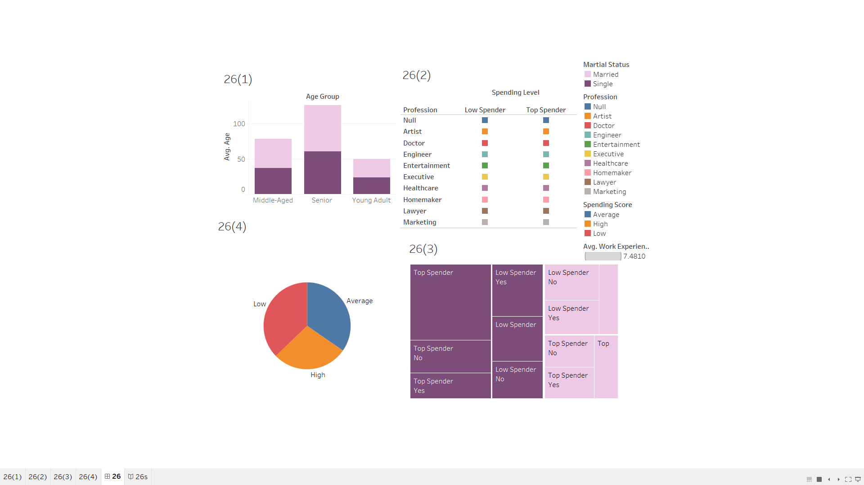

Tableau Story:

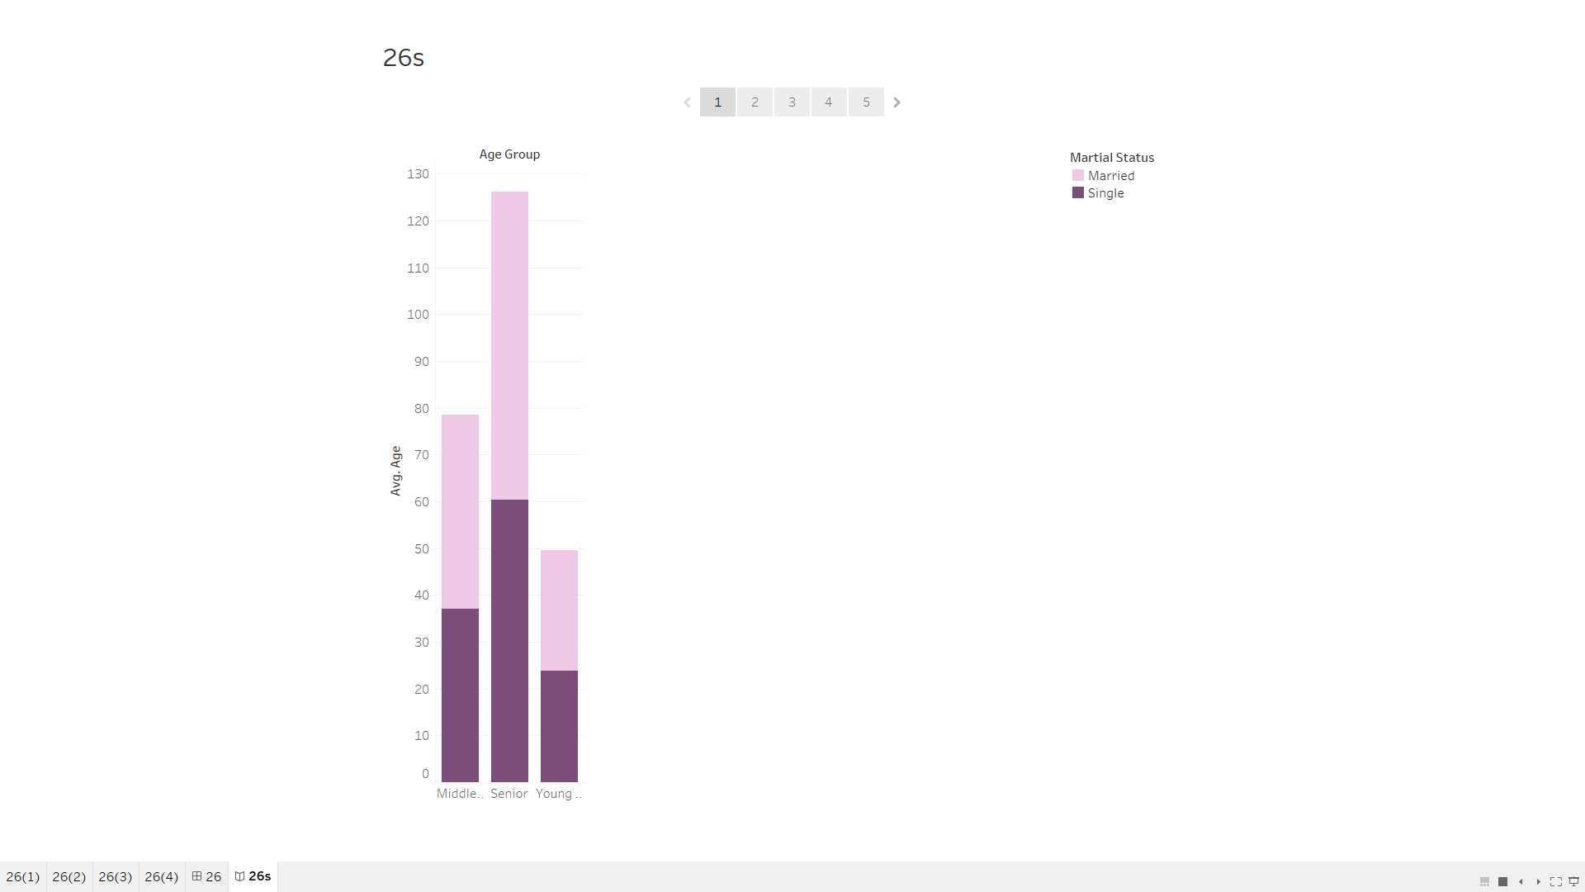

The dashboard visualizes customer segmentation using metrics like age group, spending levels, marital status, and profession. Key elements include bar charts for demographic distribution, tree maps for spender categories, and a pie chart for spending scores (low, average, high). Enhancements can include adding interactive filters for deeper analysis (e.g., by profession or age group), improving layout for clarity, and adding narratives to tell a cohesive story about customer behaviours and trends.

## 27. To study about extensions in Tableau Dashboard and try to use any two extensions.

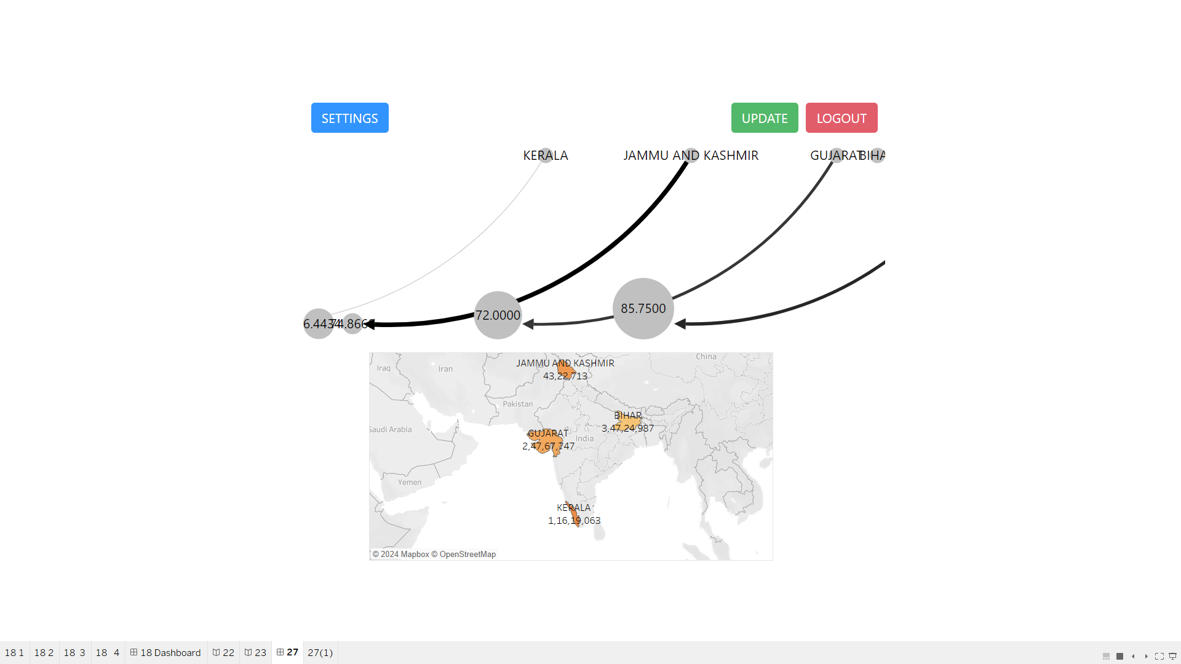

The Tableau dashboard in the image combines a network visualization and a geographic map to display data metrics linked to Indian states such as Kerala, Jammu and Kashmir, and Gujarat. Curved connectors visually represent relationships or flows between states, labeled with numerical data. Interactive buttons like "Settings," "Update," and "Logout" provide user interaction capabilities. The map below highlights the states with their respective data points, likely for comparison or analysis purposes. This setup appears suitable for analyzing regional data trends or performance metrics using interactive and visual elements.

## 28. Apply Data Blending to combine data from multiple sources to create a unified visualization, such as integrating sales data with customer demographics.

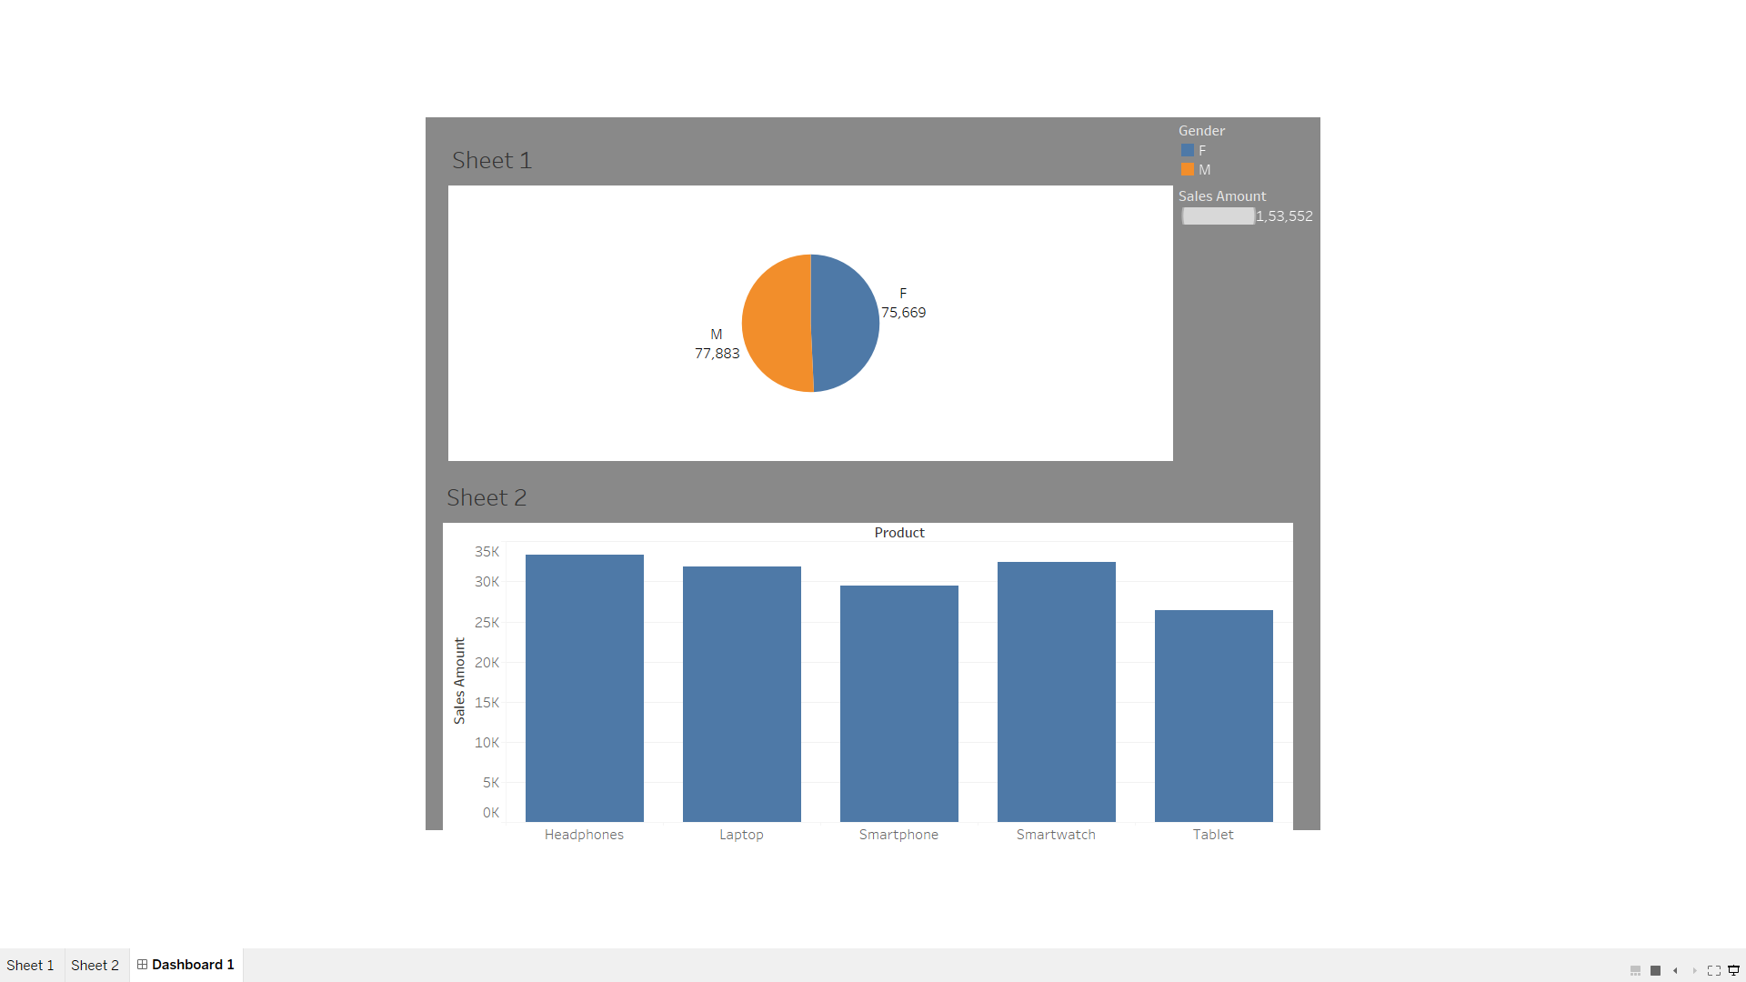

Data blending allows you to integrate data from different sources to create comprehensive visualizations that provide deeper insights. In the context of this dashboard, data blending could be used to combine sales data with customer demographics, enabling a more detailed analysis of purchasing patterns based on factors such as gender or product type. This approach would help identify which customer segments contribute the most to sales and how various products perform across demographics. By linking data from separate sources with common dimensions (e.g., customer IDs), the visualization can showcase relationships that inform better marketing and business strategies.

## 29. Create a comprehensive Dashboard and Story for Analysing Marketing Campaign Impact on Sales.

Dashboard:

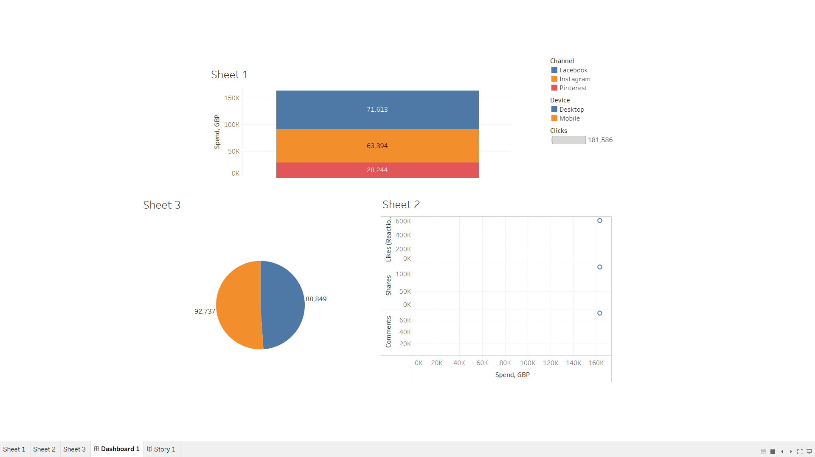

Tableau story:

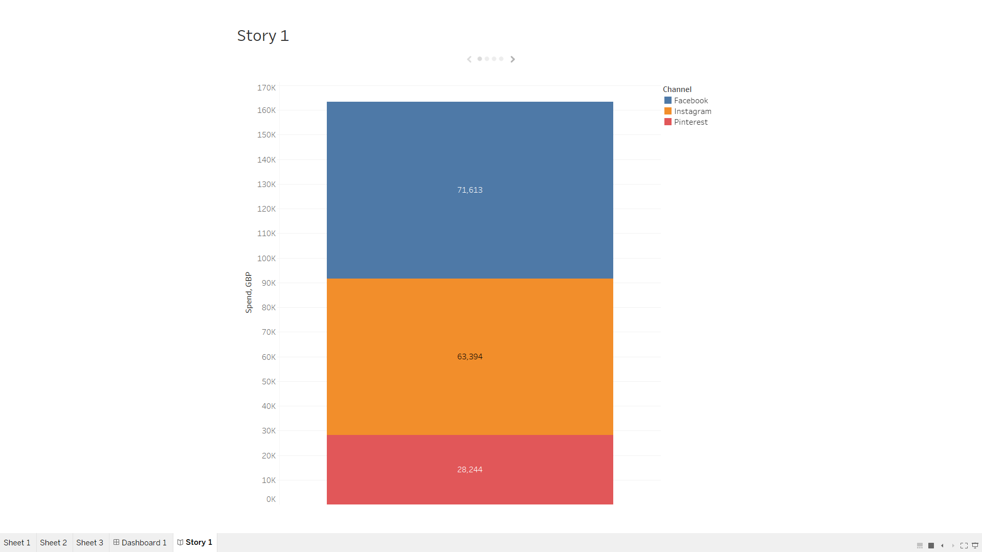

The marketing campaign dashboard and story analyzes the impact of spending across social media channels (Facebook, Instagram, Pinterest) and devices (desktop, mobile). It highlights channel-wise spending, engagement metrics (likes, shares, comments), and device usage patterns. Facebook shows the highest spend, while scatterplots reveal the relationship between spending and engagement levels. A pie chart illustrates the audience distribution or interactions. Adding filters for channels and devices and including KPIs like ROI or cost per engagement can enhance insights. This dashboard helps optimize campaign strategies by identifying high-performing channels and understanding engagement trends.

## 30. Create a comprehensive Dashboard and Story on Social Media Analytics.

Dashboard:

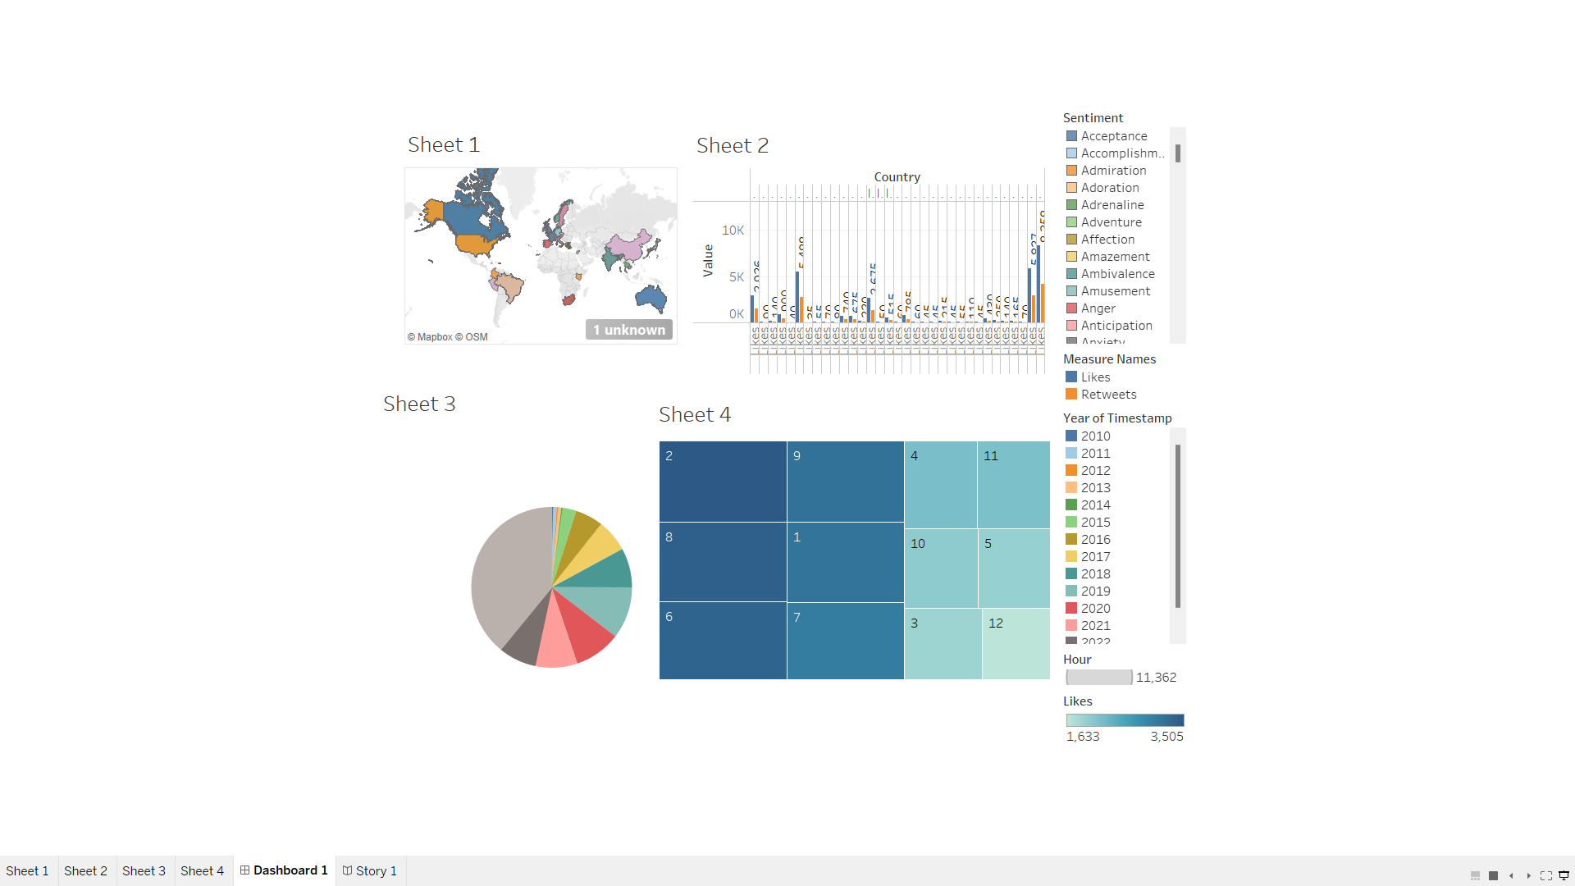

Tableau Story:

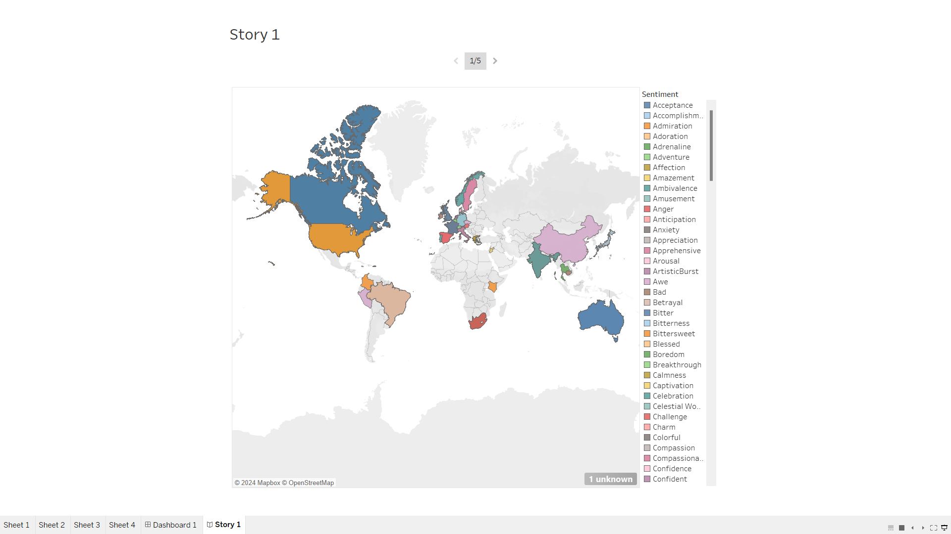

The social media analytics dashboard offers a detailed view of user engagement and sentiment trends across countries and time. It includes a map showing geographical activity, a sentiment analysis chart highlighting audience emotions, and a pie chart breaking down engagement metrics like likes and retweets. A heatmap tracks activity by year and hour, uncovering peak engagement periods. The story can focus on identifying high-performing regions, understanding user sentiments, and optimizing posting times. This tool aids in making data-driven decisions for better social media strategies.